*ESCINC Subcontract # 15-31*

*Task Order # 9*

# **Subtask 1 – Development of Integration Strategies**

# **First Revision Draft for the Summary of Developed Integration Strategies for Improved Infrastructure Assessment through the Integration of Nondestructive Evaluation (NDE) and Structural Health Monitoring (SHM) Paradigms**

Franklin Moon, Saeed Babanajad, Nenad Gucunski

18 March 2019

*This draft revision was developed on the basis of comments received from FHWA on the summary of findings that was originally drafted as required by Subtask 1, Task Order 9 issued by the Engineering & Software Consultants Inc. under the Subcontract # 15-31.*

## Introduction

The purpose of this subtask is to establish integration strategies to develop reliable estimates of structural performance and vulnerability through the correlation of simulation models and experimental data. Of particular interest for this study is the manner in which both non-destructive testing (NDE) and structural health monitoring (SHM) data are utilized to enhance the predictive capabilities of a simulation model. In essence, the primary goal is to establish the base framework to integrate two major sources of information collected by NDE and SHM campaigns in order to benefit bridge assessment practice. Importantly, it is not the intent of this research to break new ground in the interpretation of either NDE or SHM data. Rather, this effort will focus on the integration of these data sources and on evaluating the benefits of this integration over current practice.

For this research the guiding application scenario of capacity evaluation (inclusive of both the estimation of member-level demands and member-level capacity) was selected. The different approaches investigated may vary based on (a) the specific NDE data incorporated (capacity), (b) the specific SHM data incorporated (demand), (c) the parameterization of the problem (including spatial distribution), and (d) the updating strategy (deterministic, probabilistic, semi- probabilistic), among others. Following the problem statement section, the subsequent sections of this report provide a description of the fundamental components of the identified suite of integration strategies.

## Problem Statement

Over the past two decades, as the bridge engineering profession has moved towards more objective and quantitative structural assessment approaches, two complementary paradigms that focus on quantifying local and global condition/performance have emerged. In general, the local techniques fall under the NDE moniker and aim to characterize local material properties and/or identify material-level forms of deterioration or damage. The more global techniques are commonly referred to as structural testing or SHM, and generally focus on quantifying or identifying changes in more system/component-level behaviors such as those associated with global load path, the distribution of component actions, or the distribution of stresses within critical cross-sections. Although these two assessment strategies appear quite complementary in nature, there are very few examples of how this complementary nature can be exploited to improve the accuracy and comprehensiveness of bridge assessment. To fill this gap, the primary focus of this study is to develop and evaluate potential strategies for integrating common SHM and NDE data types for load rating purposes. As mentioned previously, while there are many opportunities to improve upon current NDE and SHM approaches, such improvements are outside the scope of this effort.

As described in the introduction above, capacity evaluation was selected as the guiding application scenario for the proposed research. This scenario represents the most common, quantitative assessment activity undertaken by state transportation agencies throughout the U.S., and as such is highly relevant to current bridge engineering practice. Prior to embarking on research to integrate NDE and SHM data to improve capacity evaluation, it is first necessary to structure the common practices to better understand which aspects may benefit from specific data. Towards that end, it is useful to break bridge capacity evaluation into two activities: estimation of member demands and the estimation of member capacities (as illustrated in Fig. 1 and described in the following subsections).

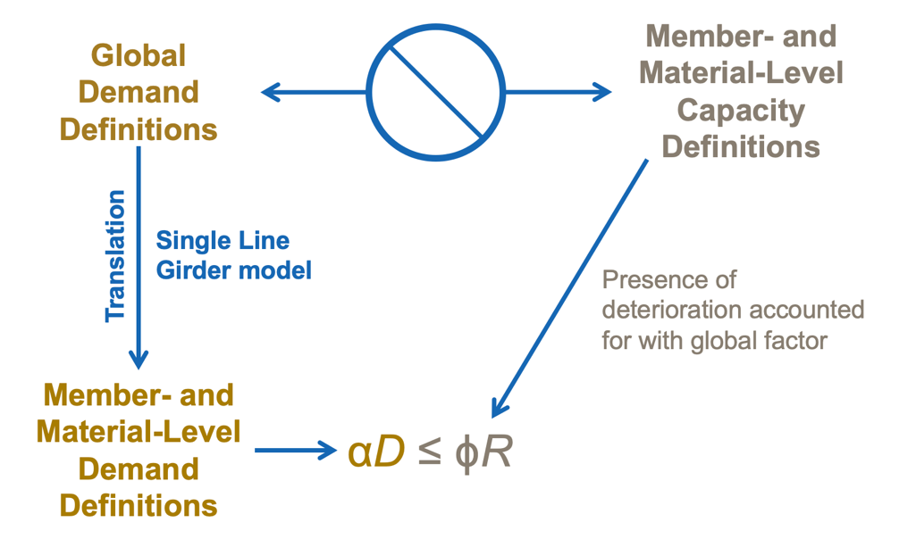

**Figure 1 Schematic of current load rating procedures**

### Estimation of Member Demands (Force Effects)

Although it is common practice for demands to be defined at the system-level (e.g. live loads, dead loads, etc.), capacity evaluation is generally carried out at the member- or component-level. This disconnect between scales requires the ability to relate globally applied loads to their corresponding member actions/force effects (e.g. moment, shear, axial, torsion, or stress). These activities fall within the realm of Structural Analysis and focus primarily on the quantification of load paths, which are influenced by applied loads (spatial distribution and location), boundary and continuity conditions, and member properties (material and geometric).

Given the uncertainty associated with these characteristics, many structural testing and/or SHM applications are geared toward improving the accuracy of this translation through various model updating schemes. Reviewing the recent technical literature reveals existing of few opportunities to improve these model updating approaches through the incorporation of NDE data together with more SHM global responses (Dubbs and Moon 2015; Jang et al. 2013; Conde et al. 2017; Gheitasi and Harris 2015; Bayraktar and Altuniki 2009; Bell and Sanayei 2007; Sanayei et al. 2006, 2012; Babanajad et al. 2018; Wenzel et al. 2013; Yost et al. 2005; Agdas et al. 2016; Ghodoosi et al. 2018). For instance, Jang et al. (2013) incorporated the corrosion level assessment (by a number of field investigations) and bridge dynamic characterization (via a series of short-term full-scale experiments) for updating a finite-element model. In a different study, Conde et al. (2017) developed a multidisciplinary approach for the structural assessment of masonry arch bridges. In particular, they used non-destructive testing techniques (inclusive of GPR, laser scanning, and sonic tests) as well as a global ambient vibration testing to refine a 3-D finite element model of an historical stone arch bridge.

### Estimation of Member Capacity

The second requirement of capacity evaluation is to estimate member capacity, which is generally done at the ultimate strength limit state. Equations to compute member capacities are provided by the American Association of State Highway and Transportation Officials (AASHTO) Load and Resistance Factor Design (LRFD) Specifications, and are generally based on mechanics of materials and have been validated through numerous destructive laboratory experiments over the last several decades (AAHSTO Manual for Bridge Evaluation; AASHTO LRFD Bridge Design Specifications; AASHTO Maintenance Manual for Roadways and Bridges; NCHRP Report 312; NCHRP Report 242; NCHRP Report 234; and several ASTM and ACI Standards). Although the uncertainty associated with these expressions (as well as variability in material properties) are addressed through resistance factors (see Fig. 1), the influence of deterioration on member capacity is generally treated in a smeared manner as per the AAHSTO Manual for Bridge Evaluation (MBE). Specifically, a condition factor may be applied (depending on the results of visual inspection) to reduce the member capacity by specific percentage. However, since these factors ignore both the underlying mechanics and the influence of the deterioration on these mechanics, the conservatism and accuracy of this approach remains uncertain.

In addition to the use of smeared, condition factors (designated as **φ*c***), the AASHTO MBE also states that the “effective area of members to be used in calculations shall be the gross area less that portion which has deteriorated due to decay or corrosion.” Little guidance, however, is provided as to (1) how deterioration (particularly internal deterioration) is to be identified and characterized, and (2) how such areas of deterioration should be considered within the capacity expressions (aside from a reduction of area). Importantly, in certain circumstances deterioration may not just serve to reduce the effective area of a member, but also modify its behavior such that assumptions implicit within the capacity equations (e.g. plane sections remain plane) are no longer valid (Weidner 2012; Zhou et al. 2012). As a result, quantifying the influence of deterioration on member capacity presents a remarkable opportunity for the use of NDE data. Specifically, NDE provides two advantages over the conventional approaches. First, NDE provides the ability to detect and characterize deterioration not visible from the surface (i.e. deterioration that would likely be missed through common visual inspection approaches). Second, NDE provides a means to quantify the extent of deterioration, which may be used to directly update models employed to compute member capacity (ACI 228.2R 98; ASNT Handbook; Andrade 1996; ASTM C 805; ASTM D 4788; ASTM D7046; ASTM D4580; ASTM C876; ASTM E2884; ASTM E709; ASTM E165; ASTM E1417; ASTM D6087; ASTM E647; ASTM C1383). As a result, NDE provides the potential to incorporate deteriorating within the member capacity evaluation process in a manner that is consistent with the underlying mechanics.

## Proposed Integration Strategy Framework

The proposed integration strategy involves using (a) global (SHM) and local (NDE) data to improve the estimation of member-level demands, and (b) local (NDE) data to improve the estimation of member-level capacity. These items are critical for accurate capacity evaluation, especially in the case of aging bridges where the use of design assumptions do not appropriately reflect the actual behavior and/or influence of deterioration. Example sources of uncertainties that often influence the accuracy of conventional capacity evaluation approaches are listed in the following:

* Demand Mechanism
  + - More effective transverse distribution of loads than reflected in the live load distribution factors
    - Non-ideal boundary and continuity conditions
    - Differences between assumed and in-situ material properties
    - Participation of “non-structural” components such as sidewalks and barriers
    - The influence of local deterioration on the distribution of force effects
* Capacity Mechanism
  + - Local material- and element-level deterioration:
* Cracking
* Spalling
* Corrosion
* Material degradation
* Debonding (overlay)
* Welding defects
* Void
  + - Local dimensional variations:
* Rebar cover depth
* Rebar location
* Element dimensions (primarily thickness)
* Tendon profile (prestressed construction)
  + - Differences between assumed and in-situ material properties:
* Elastic material properties
* Material compressive and tensile strength
* Grout condition in ducts (pre/post-tensioned)

Fig. 2 provides a schematic of an approach to reduce the influence of these sources of uncertainty and improve capacity evaluation through high-resolution NDE and global SHM approaches. By leveraging the information available through these technologies, the accuracy of calculated rating would be improved, which in-turn would provide a more reliable basis for long-term management decisions.

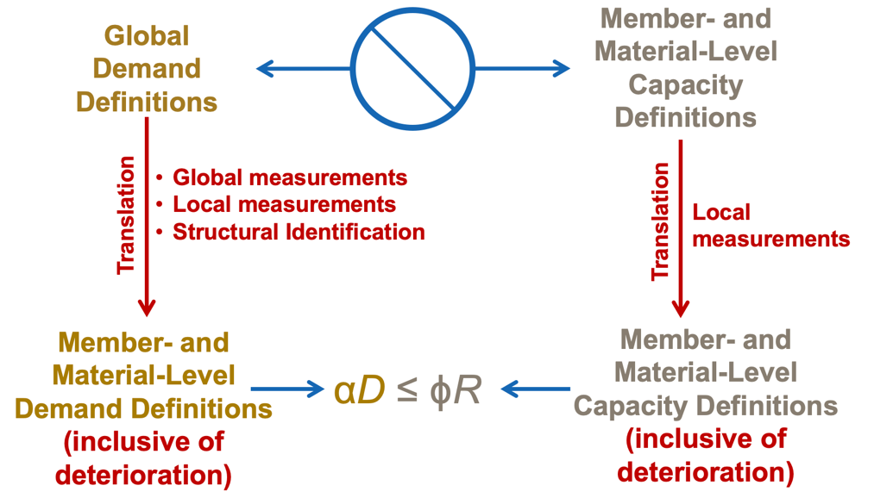

**Figure 2 The ultimate target for the proper estimation of demand and capacity**

To address the above issues, the proposed integration strategies would include a number of fundamental components to connect the diverse data available through modern NDE and SHM techniques. Fig. 3 shows a schematic of the proposed framework for this research project, with Steps 1-4 comprising the core of the integration strategy. The following subsections provide detailed descriptions of these four components.

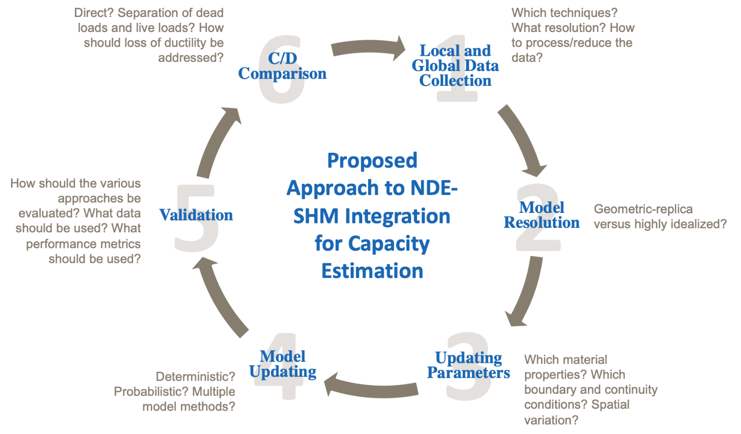

**Figure 3 Proposed approach to NDE-SHM integration for capacity estimation**

### 1. Local and Global Data Collection

Both NDE and SHM are capable of generating large volumes of data that may be processed and reduced in a number of different ways to make them usable for model updating purposes. As already discussed in the technical literature, several studies employed the NDE and SHM data (in terms global and local) to refine the model simulations. Although not all tried to integrate the NDE (inclusive of visual inspection) and SHM results at the same time, they all incorporate SHM or NDE results to fine tune the simulation procedures. Perhaps due to the local nature of NDE data, to date it has rarely been used within the model updating process. In contrast, SHM data is routinely used to update models as discussed previously (Dubbs and Moon 2015; He at al. 2009; Morassi and Stefano 2008).

In the case of NDE, data may be generated from a number of techniques, such as Infrared Thermography (IR), Impact-Echo (IE), Ground Penetrating Radar (GPR), Ultrasonic Surface Waves (USW), Electrical Resistivity (ER), Half-Cell Potential (HCP), and more importantly visual inspection (Gucunski et al. 2016). Such data generally has very high spatial resolution (on the order of 12 in. to 36 in. on center) in the case of bridge decks, but may be more discrete in nature in the case of girders and substructures. To address the challenge of incorporating NDE data for structural assessment, there are essentially two options, including:

(a) Direct – In this approach, processed NDE data is used to directly update the model by changing constants or connectivity in order to reflect the type of deterioration identified by NDE. The primary advantage of this approach is efficiency as it permits the data to be directly utilized without the need for sophisticated simulations, which are generally outside the capabilities of most practicing bridge engineers.

(b) Indirect– In this approach, the NDE methods would be directly simulated to allow the optimization of model parameters for minimizing the difference between the measured and simulated responses. This primary drawback of this method is that performing the model updating required is extremely computationally expensive as the simulations required time-history analysis that many have to be performed thousands of times for the optimization to converge. ~~multi-physics simulation software~~

As this is a first examination of the benefits of integrating NDE and SHM data for the practice of bridge engineering, the simpler, direct approach to including NDE data (a) will be utilized. However, it is worth mentioning that examining the relationship between (a) and (b) could be a very valuable follow-up study to enhance the accuracy, precision, and confidence of NDE data interpretation (especially related to non-uniqueness).

To implement the direct approach it is first necessary to reduce or interpret the available NDE data to provide information about the spatial distribution of concrete deterioration, corrosion, cracks and delamination, section loss, and material properties so they may be included within the model. Once this representation of the physical presence of various forms of deterioration is developed, it may be directly employed to update models or used as a damage function together with global data collected through the SHM campaigns. To be more specific, USW or IE data could be good examples of the high-resolution NDE data being collected from bridge decks with such characteristics. In order to “prepare” the USW or IE data for use in model updating, it is first necessary to process the data and generate spatial maps that have a resolution compatible with common FE models (e.g. 12 in. by 12 in. elements). In the case of USW, this would take the form of defining the spatial distribution of concrete modulus for the elements throughout the deck. For IE data, this would take the form of the spatial distribution of delamination, which may be modeled through modifying the effective thickness of the deck elements.

In the case of structural testing or SHM, the data has a very low spatial resolution in comparison to NDE data. For example, in the case of a load test on a typical multi-girder bridge, it would not be uncommon to only employ a few strain gages at mid-span and in the vicinity of any cross-sectional changes of the girders. Given this low spatial resolution, it is generally straightforward to directly include the data (following conventional processing) directly within the model updating process. It is envisioned that this research will focus on the following three types of global data:

* Live load-driven response data – strain, displacement, rotation
* Temperature-driven response data – strain, displacement, rotation
* Modal/dynamic data – frequencies, mode shapes, damping

For the purpose of this study, a number of assumptions have been made to better initiate the investigation of NDE-SHM integration strategies. First, only the bridge structures with concrete deck (inclusive of multi-girder composite, reinforced concrete, and pre-stressed concrete) were selected for this study. The orthotropic, cable-stayed, truss, arch, and timber bridges were excluded from the study. Second, only the bridge deck and superstructure elements were explicitly included within the integration model with the influence of substructures/foundations considered through parametrized boundary conditions. The following subsections summarize the overall concept for implementation and integration of the data collected through NDE and SHM campaigns.

#### 1.1 NDE Data Collection – Estimation of Member Capacity

The [NDE web manual](https://fhwaapps.fhwa.dot.gov/ndep/Default.aspx) published by Federal Highway Administration (FHWA) was used as the primary reference to extract the commonly employed NDE methods within bridge engineering practice. The primary goal here is to identify the available NDE methods and the type of deterioration that they can find/characterize. The influence that the resulting deterioration has on structural capacity will be assessed through nonlinear simulation. The manual is assumed to accurately list all the available NDE techniques in the field. One of the remarkable advantages of the NDE web manual is its applicability as a “problem-focused” tool as opposed to a “technology-focused” one. That is, the manual presupposes the common case where a practitioner has already identified a specific infrastructure element and/or type of anticipated deterioration or defect and is seeking an NDE technology (or technologies) to provide better characterization. Through a simple interface, shown in Fig. 4, users can search for technologies relevant to specific materials, types of deterioration, and/or infrastructure elements and can easily find definitions and descriptions of unfamiliar terms through the comprehensive glossary.

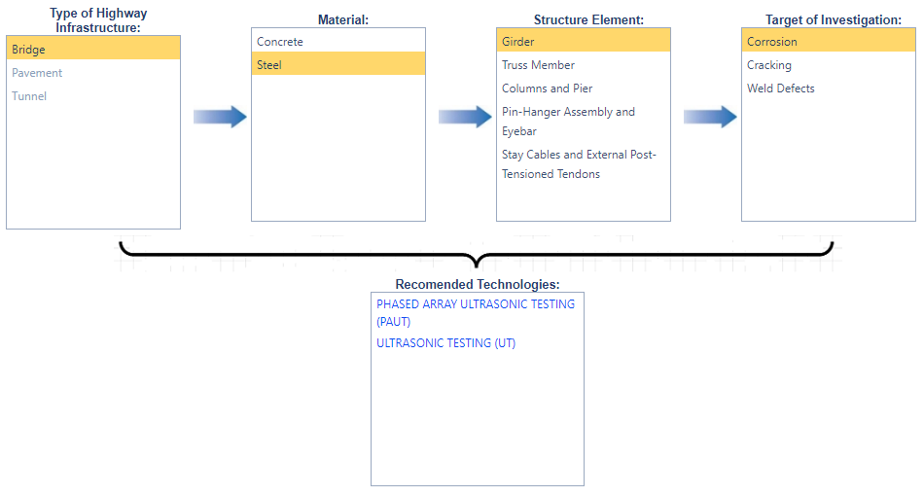

**Figure 4 Snapshot of the FHWA NDE web manual**

To employ the collected NDE data into the estimation of member capacity, it is necessary to translate the data into estimates of certain characteristics such as concrete degradation, the presence of delamination, section loss, and material properties, among others. Table 1, Table 2, and Table 3 list all the conventional NDE technologies extracted from the NDE Web Manual for deck, superstructure (if concrete), superstructure (if steel) evaluations, respectively, and define the deterioration mechanism/material property that they may be used to characterize. For the full description of the NDE technology abbreviated names, refer to the Appendix I. More detailed descriptions of member capacity estimation will be discussed in the following sections (Section 2.2, Section 3, and Section 4.2).

**Table 1 The corresponding model attributes for different NDE technologies used for bridge decks**

|  |  |  |  |
| --- | --- | --- | --- |
| **Structural Defect** | **Type of Issue** | **Corresponding NDE Tests** | **References** |
| Deterioration | Cracking | IE, USW | ASTM C1383; Sansalone and Carino 1989; Gucunski et al. 2013; Azari et al. 2012; Gucunski et al. 2011; ACI 228.2R |
| Corrosion | ER, GPM, GPR, HCP, LPR, MFL | Gucunski et al. 2013; Gucunski et al. 2011; Sørensen and Frølund 2002; Elsener et al. 1996; Bäßler et al. 2003; ASTM D6087; ASTM C876; Millard 2003; Stern 1957; Andrade 1996; Ghorbanpoor et al. 2000; McGogney 1995 |
| Degradation | GPR, USW | ASTM D6087; Gucuski et al. 2013; Gucunski et al. 2011; ACI 228.2R; Azari et al. 2012 |
| Delamination | GPR, HSCD, IE, IR, RH | ASTM D6087; Gucuski et al. 2013; Gucunski et al. 2011; ASTM D4580; Gucunski 2013; ASTM C1383; Sansalone and Carino 1989; Azari et al. 2012; Maierhofer et al. 2006; Washer et al. 2008; ASTM D4788; ASTM C805; Szilẚgyi et al. 2010 |
| Overlay Debonding | HSCD, IE, IR | Gucunski et al. 2013; Gucunski et al. 2011; ASTM D4580; Gucunski 2013; ASTM C1383; Sansalone and Carino 1989; Azari et al. 2012; Maierhofer et al. 2006; Washer et al. 2008; ASTM D4788 |
|  | Void | GPR, IE, IR | ASTM D6087; ASTM C1383; Sansalone and Carino 1989; Gucunski et al. 2013; Azari et al. 2012; Maierhofer et al. 2006; Washer et al. 2008; ASTM D4788 |
| Dimensional/Mechanical | Rebar Cover Depth | GPR, MM | ASTM D6087; Bray and Stanley 1989; ASTM D7046 |
| Rebar Locating and Mapping | GPR, MM | ASTM D6087; Bray and Stanley 1989; ASTM D7046 |
| Thickness Measurement | GPR, MM, UPE | ASTM D6087; Bray and Stanley 1989; ASTM D70461; Kozlov et al. 2006; ACI 228.2R |
| Material Properties | Materials Characteristics | Material- level assessment tests (concrete compressive/tensile strength, elastic modulus, unit weight, chloride ponding) | ASTM G109; ASTM C469; ASTM C1152; ASTM C944, etc. |

**Table 2 The corresponding model attributes for different NDE technologies used for bridge superstructure (concrete)**

|  |  |  |  |
| --- | --- | --- | --- |
| **Structural Defect** | **Type of Issue** | **Corresponding NDE Tests** | **References** |
| Deterioration | Cracking | IE, USW | ASTM C1383; Sansalone and Carino 1989; Gucunski et al. 2013; Azari et al. 2012; Gucunski et al. 2011; ACI 228.2R |
| Corrosion | ER, GPR, HCP, MFL | Gucunski et al. 2013; Gucunski et al. 2011; ASTM D6087; Gucunski et al. 2011; ASTM C876; Ghorbanpoor et al. 2000; McGogney 1995 |
| Degradation | GPR, USW | ASTM D6087; Gucunski et al. 2013; Gucunski et al. 2011; ACI 228.2R; Azari et al. 2012 |
| Delamination | GPR, HSCD, IE, IR, RH | ASTM D6087; ASTM C1383; Sansalone and Carino 1989; Gucunski et al. 2013; Azari et al. 2012; Maierhofer et al. 2006; Washer et al. 2008; ASTM D4788 |
| Grouting Condition (inside ducts) | GPR, IE, IR | ASTM D6087; ASTM C1383; Sansalone and Carino 1989; Gucunski et al. 2013; Azari et al. 2012; Maierhofer et al. 2006; Washer et al. 2008; ASTM D4788 |
| Void | GPR, IE, IR, RAD | ASTM D6087; Mariscotti et al. 2009; ASTM C1383; Sansalone and Carino 1989; Gucunski et al. 2013; Azari et al. 2012; Maierhofer et al. 2006; Washer et al. 2008; ASTM D4788 |
| Dimensional/Mechanical | Profiling Tendons | GPR, MM, RAD | ASTM D6087; Bray and Stanley 1989; ASTM D7046; Pimentel et al. 2010; Mariscotti et al. 2009 |
| Rebar Locating and Mapping | GPR, MM | ASTM D6087; Bray and Stanley 1989; ASTM D7046 |
| Material Properties | Materials Characteristics | Material- level assessment tests (concrete compressive/tensile strength, elastic modulus, unit weight) | ASTM G109; ASTM C469; ASTM C1152; ASTM C944, etc. |

**Table 3 The corresponding model attributes for different NDE technologies used for bridge superstructure (steel)**

|  |  |  |  |
| --- | --- | --- | --- |
| **Structural Defect** | **Type of Issue** | **Corresponding NDE Tests** | **References** |
| Deterioration | Cracking | AE, CPG, PT, ECA, ECT, MT, PAUT, UT | ASNT Handbook 2005; Huang et al. 1998; ASTM E647; ASTM E1417; ASTM E165; ASTM E2884; Hagemaier 1990; ASTM E709; Olympus NDT 2007; AWS D1.5; Moore et al. 2004 |
| Corrosion | PAUT, UT | Olympus NDT 2007; AWS D1.5; Moore et al. 2004 |
| Dimensional/Mechanical | Weld Defects | PT, ECA, ECT, MT, PAUT, UT | ASTM E1417; ASTM E165; ASTM E2884; Hagemaier 1990; ASTM E709; Olympus NDT 2007; AWS D1.5; Moore et al. 2004 |
| Material Properties | Materials Characteristics | Material- level assessment tests (steel tensile strength, elastic modulus, fatigue) | ASTM A615; ASTM D7913, etc. |

In order to modify the conventional structural models, only certain characteristics can be altered to become more consistent with the data obtained from NDE or SHM techniques: geometric properties, materials characteristics, boundary and continuity conditions, and mass (total and distribution). In the case of NDE data, most of the modifications are expected to be associated with member geometry (to reflect section loss, as-built geometry, etc.) and material properties (to reflect in-situ properties and the presence of deterioration). To accomplish this, standard approaches to NDE data interpretation (see references in the tables above) will be utilized.

#### 1.2 SHM Data Collection – Estimation of Member Demand

Depending on the type of SHM practice, it is possible to collect the structural information both in local and global level. Table 4 provides a list of common measurements obtained to improve the estimation of member-level demands. For example, the “normalized” measurements such as flexural strains captured at different levels of a steel girder would be able to approximate the location of the neutral axis, which is a good indicator of the level of composite action. Although such measurements are clearly advantageous as they are straightforward to interpret, the data they provide is primarily reflective of the state of structure in the vicinity of the sensor. As a result, the exclusive reliance on such normalized measurements is cost-prohibitive since a high spatial resolution is required to provide information about the entire structure. In contrast, more absolute measurements such as displacements, tilts, or modal parameters are able to provide information about global characteristics of a structure such as boundary and continuity conditions. In general, the accurate determination of member-level demands requires information from both types of measurements. To that extend, authors have conducted multiple studies to address efficient and accurate model updating approaches based on the local and global SHM (Weidner 2012; Yarnold and Weidner 2016; Zhou et al. 2012; Dubbs 2012; Dubbs and Moon 2015; Masceri 2015).

However, the primary goal of the integration system envisioned herein is to identify a reasonable balance between the use of “normalized” and “absolute” SHM metrics (one that is consistent with the type of data obtained within the current practice) and to further establish to what degree the inclusion of NDE data can improve the accuracy of demand estimates (Weidner 2012; Yarnold and Weidner 2016; Zhou et al. 2012; Dubbs 2012; Dubbs and Moon 2015; Masceri 2015). Importantly, it is not the intent of this study to develop new model updating strategies for incorporating SHM data. Rather, the goal is to use approaches that have shown promise (see references above) and establish to what extent including NDE data improves these approaches.

**Table 4 Local and global measurands for determination of demand level**

|  |  |  |
| --- | --- | --- |
| **SHM Measurements** | | |
| **”Normalized”** | Strain | Flexural |
| Axial |
| Shear |
| Neutral axis (composite action) |
| Load distribution |
| **”Absolute”** | Deflection | Vertical deflection and deflection basin |
| Global stiffness |
| Bearing movement |
| Joint displacement |
| Rotation | Beam rotation |
| Support rigidity |
| Temperature | Embedded |
| Surface |
| Acceleration | Modal shapes |
| Eigen values |

#### 1.3 SHM/NDE Data Fusion

During SHM/NDE campaigns, enormous amount of high resolution raw data is collected for each technology. This huge amount of data must be fused and integrated in a way that could be easily employed for simulation purposes. As already discussed in Section 1, the direct use of NDE data is the base approach in the current study to directly update the simulation models. The NDE results will be directly employed by simply changing constants or connectivity in order to reflect the type of deterioration identified by NDE.

To do so, data fusion will combine several sources of raw data to produce new fused data that carries information that may be more readily incorporated to improve simulation models (for both demand and capacity estimation). In essence, the definition of data fusion corresponds to the following data analytics on the collected data:

1. Combine multiple techniques: it is possible that two or more NDE/SHM techniques share the same meaning of a certain structural characteristic. For example, both ER and HCP techniques closely describe the level of corrosion in the concrete deck. The first one concentrates on assessment of the corrosive environment; the second one evaluates the probability of active corrosion. It is interesting that GPR has also been shown to be a good descriptor of the corrosive environment in concrete decks (Gucunski et al. 2016). This is not surprising considering that all three methods are influenced by electrical properties or processes in the deck.

Fig. 5 demonstrates the results of an analysis conducted to identify the level of agreement between HCP, ER, and GPR. The experimental tests were conducted on the Heymarket Bridge in Virginia as a part of the Long-term Bridge Performance program (LTBP) Program (Gucunski et al. 2016). The NDE tests were repeated in September 2009, August 2011, October 2014, and June 2015. Constructed in 1979, it is a two-span continuous steel girder structure with a bare reinforced concrete deck (Fig. 6) measuring 84.1 m (276 ft) long, 13.8 m (42 ft) wide, and 21.5 cm (8.5 in.) thick. The bridge has a skew angle of 17°.

The agreement in the surveys demonstrated high repeatability of the NDE measurements and high correlation between three electrical/electrochemical/electromagnetic methods: ER, HCP, and GPR. Reviewing the results reveal strong correlation (along with repeatability and consistency) between the results may assist in better detection of primary causes of structural defect. Therefore, it would be computationally effective to combine the correlated NDE tests results into a single index for model updating. One of the simplest way is to take the average of similar normalized NDE techniques’ test results (Gucunski et al. 2016).

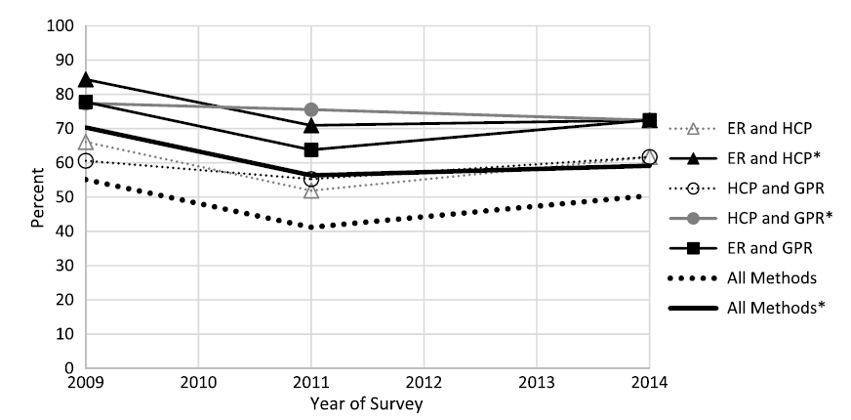

**Figure 5 Agreement between various electrical methods for assessing deterioration (*normalized based on number of HCP locations indicating sound or deteriorated condition) (Gucunski et al. 2016)**



.

**Figure 6 a) Rt. 15 over the I-66 Bridge in Haymarket, VA: (a) side view, b) NDE technologies simultaneously deployed during data collection (image by Nenad Gucunski)**

1. Data Reduction: most NDE data is collected in foot to inch resolution. While this seems to be ideal, large local variations in parameters that may arise from such data could result in complex stress patterns that have little influence on the global responses of interest. To cope with this, it is proposed that the NDE data be smoothed through either a spatial averaging or manual approach prior to using the it for updating. For example, the elastic modulus for the deck of the Heymarket Bridge would be smoothed to eliminate small, localized features but to retain the location of more appreciable changes. This could be done by defining independent parameters for the different regions or through defining a damage function that accounts for the measure spatial variation of the parameter. In the later case a single parameter is updated and multiplied by the damage function to assign values spatially across the deck.
2. Data Simulation (or Statistical Data Simulation): To represent the variability inherent in the measured NDE/SHM data appropriate probability distributions can be employed. Fig. 7, for example, demonstrates the estimated concrete modulus collected by the USW technique from the Heymarket Bridge (Gucunski et al. 2016). Changes in concrete quality described by the elastic modulus measurement using USW are quantified in Table 5. A review of the heat map reveals expansion of zones with low moduli from 2011 to 2014 and 2015. Many of the low-moduli zones marked in red are more indicative of delamination than an actual measure of concrete modulus (that is, the presence of the delamination violates some of the underlying assumptions required to estimate modulus). The overall statistics for changes in concrete modulus are described in Table 5 in terms of average modulus, standard deviation, and percentages of deck area in various modulus ranges. As quantified in the table, clear indicators of concrete quality degradation are decreased average modulus and increased spread of measured moduli expressed through standard deviation. Once in this form, the data could be readily incorporated into both capacity models through Monte Carlo sampling techniques and global models through either the definition of damage functions (to maintain the spatial distribution of this data) or through direct updating.

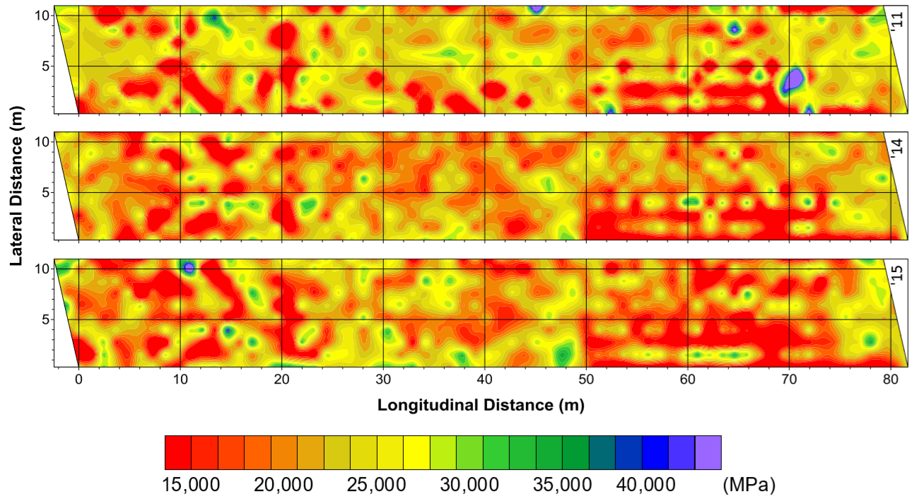

**Figure 7 Concrete modulus maps from USW testing for the Haymarket Bridge deck from 2011 to 2015**

**Table 5 Percentages of deck area with different concrete Moduli, Mean Moduli, and Standard Deviation (Gucunski et al. 2016)**

|  |  |  |  |  |  |
| --- | --- | --- | --- | --- | --- |
| **Year** | **Percentage of deck area** | | | **Mean *E* (GPa)** | **SD (GPa)** |
| < 20 GPa | 20-30 GPa | > 30 GPa |
| 2011 | 76 | 17 | 6 | 22.65 | 4.86 |
| 2014 | 79 | 17 | 4 | 20.56 | 5.95 |
| 2015 | 73 | 20 | 7 | 20.74 | 6.81 |

A similar approach can be applied for SHM data with the distinction that the statistics represent the variability with respect to time/loading/weather, not with respect to spatial variations. For instance, Fig. 8 represents a schematic view of a composite steel girder bridge cross-section (Sigurdardottir and Glisic 2013). The centroid of stiffness is a universal parameter and its position in a cross-section can be evaluated for any load-carrying beam structure as the position of the neutral axis under conveniently chosen loads. Thus, a change in the position of the neutral axis within a cross-section can indicate a change in the position of the centroid of stiffness, i.e., unusual structural behaviors. By successfully monitoring the longitudinal strains at multiple levels of the girder cross-section, it is possible to estimate the location of the Neutral Axis (NA) throughout the course of an SHM campaign. Past research has shown that the neutral axis location is temperature-sensitive and may vary even when damage is not present (Sigurdardottir and Glisic 2013). Fig. 9 represents a number of different NA measurements that were conducted in a series of continuous monitoring of the US202/NJ23 highway overpass in Wayne, New Jersey (see Fig. 10 for bridge view). Due to the inherit uncertainty associated with a number of casual variables (temperature, traffic, load patterns, boundary condition, etc.), the location of the NA has some inherent variability. As a result, a probabilistic approach is needed to properly account for this variability and its influence on (for example) load rating. One of the most conventional approaches is to fit probabilistic density functions on the collected data. For example, Fig. 8 depicts the cross-section with the theoretical locations of the NA, assuming complete composite action and no composite action, respectively. The figure also shows the histogram of the measurements and the Gaussian curve fitted to them (solid line). As a summary, having such probabilistic distribution would significantly enhance the value of the data for better and accurate model analysis. In fact, such distributions would encompass all the SHM data into more accurate and reliable format, which could be successfully deployed to drive Monte Carlo simulation, Bayesian model updating, and multi-model structural identification, among others.

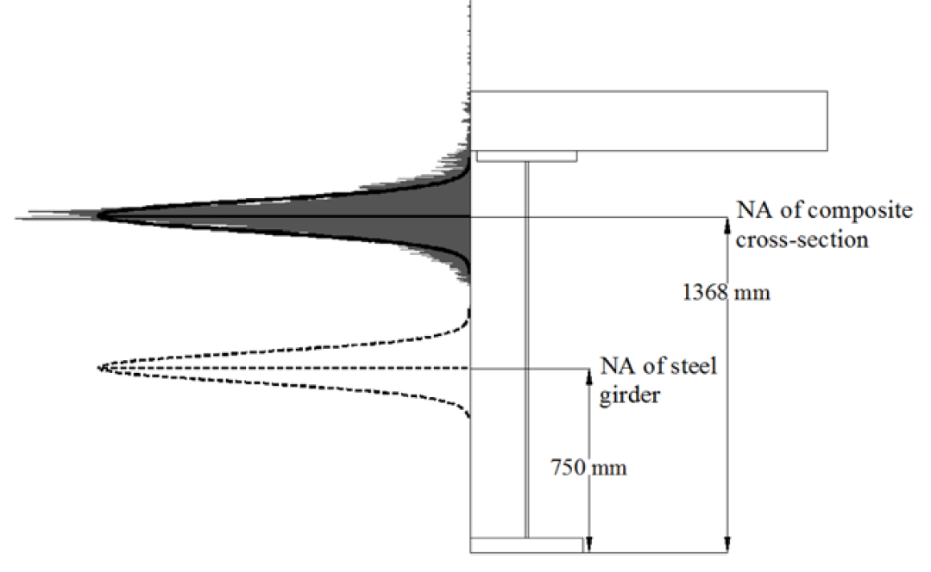

**Figure 8 Cross-section at the midspan of girder 5 with histogram of NA estimations; the solid line shows a Gaussian fit of the data with mean m =1372 mm and standard deviation = 60 mm; the dotted line shows the same Gaussian curve centered around the centroid of the steel girder only (Sigurdardottir and Glisic 2013)**

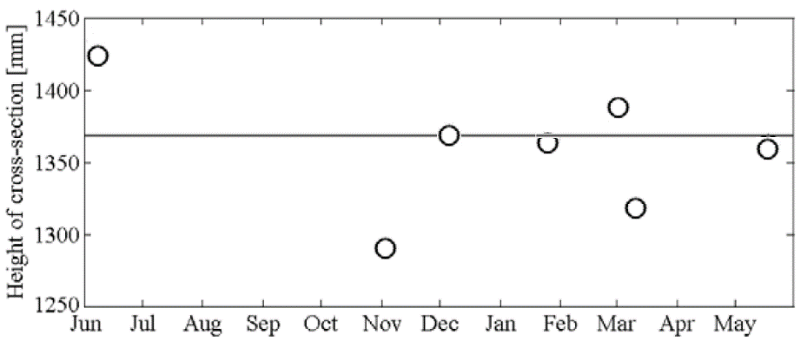

**Figure 9 Location of the neutral axis as estimated by the mean of a Gaussian fit for seven measurement sessions (Sigurdardottir and Glisic 2013)**

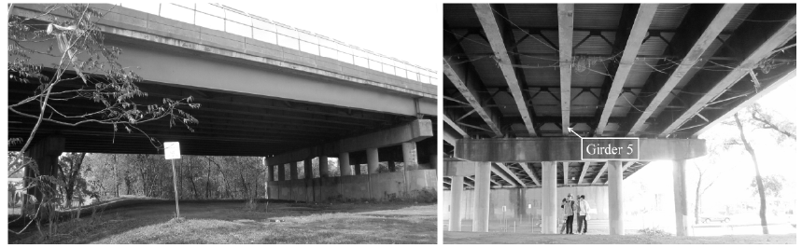

**Figure 10 Span 2 of US202/NJ23. (a) North and southbound, (b) Supports at the south end of the southbound span (Sigurdardottir and Glisic 2013)**

Statistical data simulation is powerful tool and is commonly used for all types of measurements that have appreciable levels of uncertainty and inconsistency. For instance, Fig. 11 represents the result of a GPR survey on one of the Mid-Atlantic bridges tested throughout the LTBP program. It is clear that the measured cover depth is a good example of considering probabilistic distribution throughout the model updating. However, as with all tools, this approach is not without its downsides. Chief among them is the potential for masking deterministic mechanisms by improperly grouping data. As a simple example of this danger, consider the case where one side of a bridge deck experiences significantly more deterioration than the other. In such a case, grouping all of the data together to obtain one set of statistics is wholly inappropriate. Rather, in such a case, the spatial characteristics of the data should be retained through the use of probability distributions that vary spatially or through the fitting of multiple distributions. The same challenge applies to SHM data, but instead of spatial variability, the primary concern is temporal variability. For example, the NA data shown in Fig. 8 cannot be modeled with a single distribution as the deterministic influence of temperature on the underlying behavior would be distorted. This is a rather obvious example, but it is illustrative of the need to ensure that the data is not inappropriately grouped for fitting probability distributions.

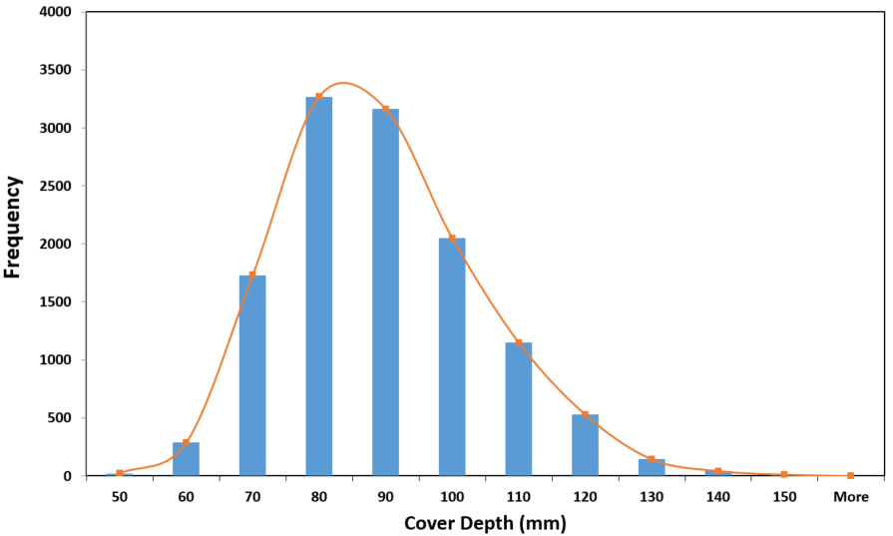

**Figure 11 Histogram of cover depth for a concrete bridge deck tested through LTBP Program**

### 2. Model Resolution

#### 2.1. Demand Models

One of the most important aspects of model updating is the selection of model resolution. In general, these decisions need to be made on the basis of two main competing influences. The first corresponds to the ultimate goal of the application. To estimate member-level demands, for example, a high-level phenomenological-type model will not be able to appropriately satisfy the necessary requirements. In contrast, such model will be sufficient if the ultimate target is to estimate dynamic characteristics to diagnose objectionable levels of vibration. In essence, the ultimate target of model analysis would determine the minimum acceptable model resolution. In order to conceptualize a constructed system, it is highly recommended to start with a greatly idealized phenomenological geometric models together with the site, soil and foundations, and then gradually increasing the detail and complexity of the model as the system is better investigated (Dubbs 2012). The following sections provide brief discussions and examples of the most common physical-based models employed for modeling purposes.

##### 2.1.1. Phenomenological Models

This method is the most basic and commonly used approach for the design and performance evaluation of common bridge types within the U.S. This class of models consists of the lowest geometric resolution with only few elements to define the key response mechanisms of the actual systems (Fig. 12). This approach approximates structural behavior (in particular the transverse distribution of demands) through various approximate equations to estimate the equivalent demands a girder within the structural system will experience. In most cases, simple one- dimensional (e.g. plane or space frame elements) and discrete elements (e.g. translational or rotational springs, point masses) are employed for constructing such models (Dubbs 2012). This approach has been shown to under-estimate stiffness, but is generally conservative for the computation of dead and live load actions, and thus is well-suited for design applications.



**Figure 12 Phenomenological model example**

##### 2.1.2. Structural Models

For structural identification purposes, structural models are perhaps the most commonly used class of models (Fig. 13). One-dimensional (plane or space frame elements) and two-dimensional elements (e.g. plate or shell elements) are employed to simulate the response of primary components. Various link elements, constraints, and rigid offsets are often employed in order to simulate the 3D geometry of structural elements. This class of modeling permits the user to easily simulate more detailed responses without the need to rely on simplified approximate methods. Such measures allow the impact of various member-level continuity and boundary conditions on the overall response to be assessed. Compared to phenomenological models, however, their construction and error screening is far more time consuming and tedious (Dubbs 2012).



**Figure 13 Structural model example**

##### 2.1.3. Finite Element Models

This class of modeling has the finest geometric resolution, and in some cases may consist of a geometric-replica model (Fig. 14). To create such high-resolution simulations, these models employ the full range of finite elements available including three-dimensional solids. Through these models, it is possible to simulate the response of complex structural details (including connections, contacts, stress concentration, non-linearity, etc.). In return, they are extremely challenging and expensive to construct and error screen in a reliable manner (Dubbs 2012).

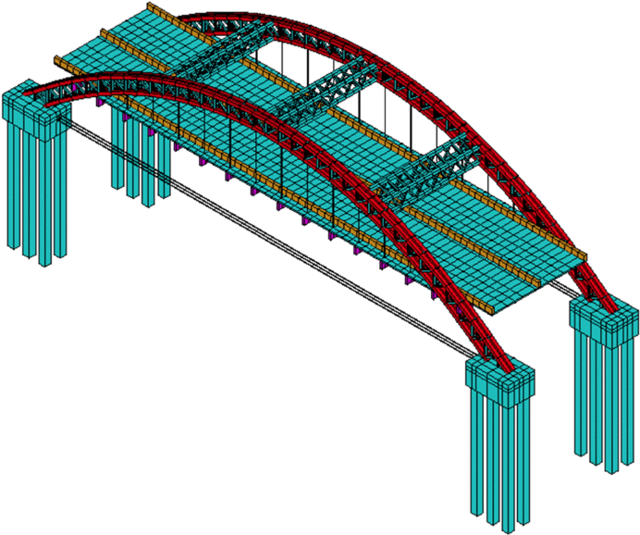

**Figure 14 FE model example**

##### 2.1.4. Proposed model resolutions for regular highway bridges

For the current NDE-SHM, as shown in Fig. 15, multiple levels of model resolutions are proposed. The level of the model resolution is simulated by increasing the dimension of the elements being employed to construct the structure’s model. In particular, model resolution varied by using frame and link (1-D element), shell (2-D), and solid (3-D) elements. The proposed model resolution is conducted in a sequential manner wherein Fig. 15a pertains to the simplest model that could be constructed for a multi-girder composite bridge, where some of the NDE/SHM could be incorporated to refine the model attributes. In this model, one beam element (1D) is considered at each cross section of the girder to model the girder. Except the deck, where shell elements (2D) are employed for modeling deck, any secondary bridge component such as bracings, stiffeners, cross frames, and diaphragms could not be explicitly considered and so their contribution must be account for by modifying the transverse stiffness properties of the deck elements. Implementation of rigid links and offsets could be still counted but in a more smeared manner.

Fig. 15b illustrates a higher resolution model where the girder and diaphragm elements are simulated through shell elements. While keeping the same shell element for the deck, the connection and offset between the multiple girder elements and the deck are simulated through a number of link elements, which act to enforce strain compatibility between the various elements. Through this level of model resolution, it is now possible to explicitly simulate cross bracing or diaphragms. Due to the capability of the proposed model resolution, the boundary conditions and continuity (which are very crucial to the dynamic analysis of the structure) could be perfectly simulated at the girder ends, abutments, or piers. As shown in Fig. 15c, having such resolution will also help in incorporating the SHM and NDE data to assign different geometrical and material characteristics for the elements. The authors have previously conducted several studies on defining different model updating resolution techniques and have utilized a variety of structural characteristics (inclusive of geometrical and material) for model refinement (Weidner 2012; Yarnold and Weidner 2016; Zhou et al. 2012; Dubbs 2012; Dubbs and Moon 2015; Masceri 2015). Such models represent a good balance between ease of use and accuracy as evidence by their common usage for simulating highway bridges. In a finer resolution, it is possible to divide every single elements into a number of solid elements, however, this would not be a feasible case for the purpose of NDE-SHM integration.

Although it is possible to examine more refined models, at this stage (and based on past experience) the research team believes that the marginal benefits that may be gained cannot be justified when weighed against the significant increase in complexity. This is further supported by the desire for this project to produce results that are implementable in practice, as the vast majority of consultants do not have the ability to implement new element types or perform multi-physics simulation. As a result, this study aims to develop and examine strategies that combine common NDE and SHM data within common model updating approaches that are compatible with current practice. Fig. 16 schematically illustrates the trade-off between model resolution, accuracy of demand estimation, and the complexity of computation. The exponential curve illustrates that while the accuracy of demand estimation may show significant improvement at lower model resolution (e.g. *a* to *b* to *c*); however, at higher model resolutions (e.g. *c* to *d*) only marginal gains in demand estimation are observed. In addition, to achieve this marginal improvement in demand estimation, a significant increase in model complexity must be managed. This increased complexity requires more resources to construct, error screen, and interpret simulation results, places severe constraints on the type of model updating approaches that may be practically employed, and generally requires far more experienced analysts to execute properly.

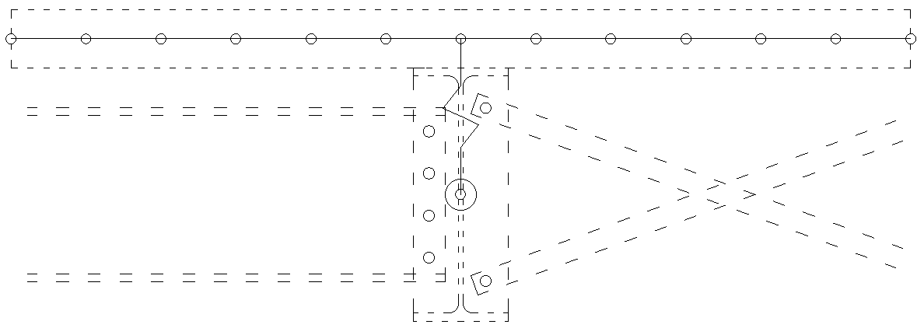

(a)

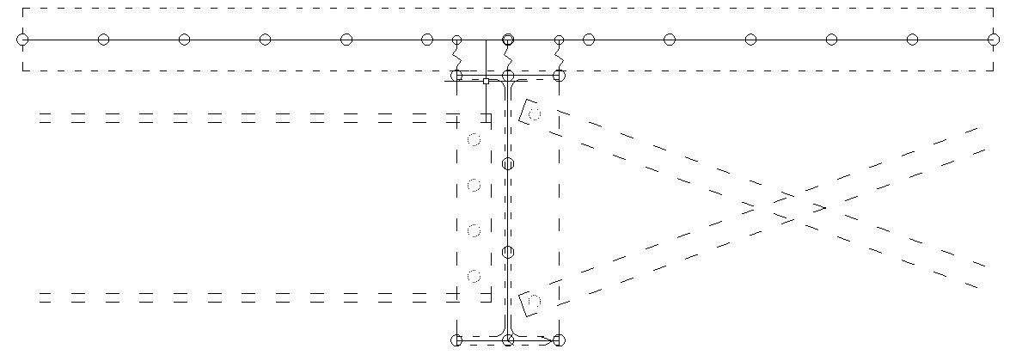

(b)

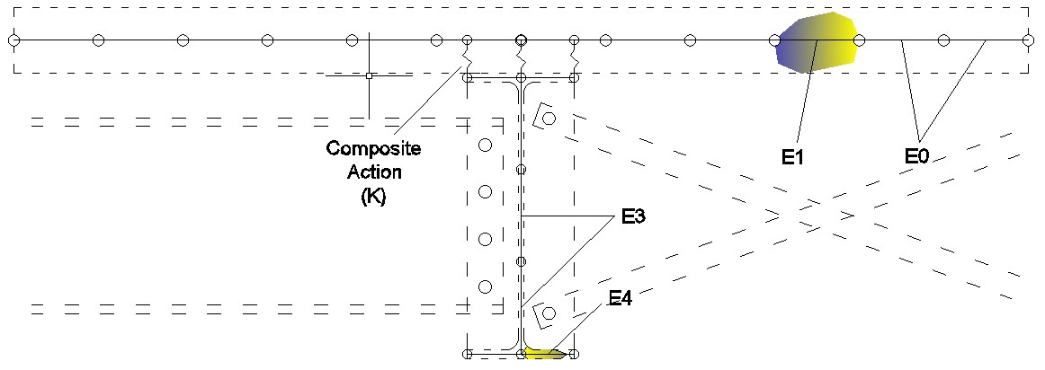

(c)

**Figure 15 a-b) Progressive model resolutions, c) corresponding model attributes to the NDE-SHM data**

**Figure 16 Progressive model resolutions, where A, B, and C refer to models with a combination of frame (1D) and shell (2D) elements. Model D refers to the resolution where all the elements are composed of very fine solids**

The second (and competing) influence on model resolution is related to the type and spatial resolution of the data that may be available to perform the updating. In the case of global response measurements, it is not uncommon to constrain the available data to strain and displacement measurements in a few critical locations or to five or ten modal frequencies and mode shapes. The challenge in these cases is that when higher resolution models are employed the number of their uncertain parameters far outweigh what may be identified by the rather sparse data available. It is important to recognize that this disconnect between a relatively high-resolution model and relatively sparse data available for updating is not an exception, but the rule for constructed systems (due to their size and complexity as well as the cost of data collection). The result of this disconnect is an increase in the non-uniqueness of the updating problem, which can be managed and reduced if the use of overly complex models are avoided.

#### 2.2. Capacity Models

For the estimation of member-level capacity, it is generally not common to employ a model per se, but rather to simply use the expressions provided by the AASHTO LRFD Specifications (and referenced by the AASHTO MBE). Although this is convenient, it does not permit the analyst to directly incorporate the presence of deterioration or damage and quantify its influence on member capacity. As a result, for this application the use of a cross-sectional model termed a fiber model will be employed. This model is commonly used for nonlinear flexural analysis of complex cross-sections, which it handles by discretizing the cross-section into a number of elements referenced to specific stress-strain models. Through incrementally increasing the curvature on the cross-section (together with assumptions of plane-sections-remain-plane and iterating until equilibrium is satisfied) a nonlinear moment-curvature response is obtained. Fig. 17a schematically shows a section of multi-girder composite bridge with a cross-sectional cut. Fig. 17b gives a closer look at the fiber cross-section, where all the girder and deck elements are meshed into finer 2D elements. This would facilitate to efficiently incorporate the results of NDE (in terms of deterioration) in the capacity estimation for any critical section of the structure.

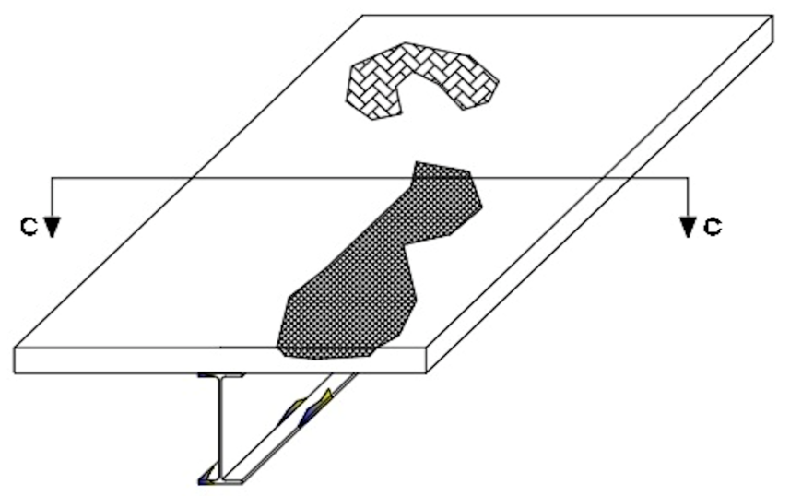

(a)

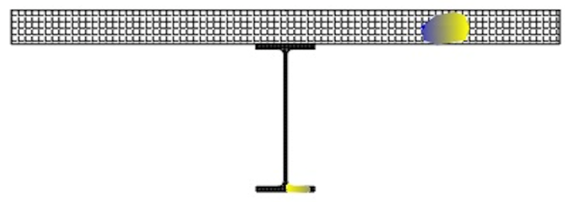

(b)

**Figure 17 a) 3-D schematic of a deteriorated bridge, b) fiber model for a critical cross-section (C-C)**

This model is proposed as it represents the simplest approach to estimate the capacity of members with deterioration and damage (which may be simulated through modification of the corresponding stress-strain models). However, influences that require the longitudinal dimension to be simulated (e.g. effective width, development, stability, changes in strain compatibility relationships, etc.) cannot be directly simulated by this model type and would need to be incorporated through appropriate modifications of the stress-strain models. If this proves too limiting for the application scenario, the research team will move to more refined FE-based capacity models, which can handle these aspects, but are far more time-consuming to implement.

For implementation purposes, based on past experience, it is outlined to employ Strand7 and MATLAB software platforms. The Strand7 will be used for building and analyzing the models, and MATLAB will be utilized for programming and extracting the I/O variables. As discussed, the ultimate goal of this study is to address the NDE-SHM integration for current bridge engineering practice and the proposed strategies should be implementable in any commercially available software platforms.

### 3. Updating Parameters

In general, it is important that the model parameters selected for updating have two attributes: (1) they should be identifiable using the available data, and (2) they should have an influence over the desired simulation result (in this case capacity evaluation). Both of these criteria are generally met through a series of sensitivity analyses. For the first criterion, the magnitude of the measured data is varied and the resulting impact on various parameters is quantified. Parameters that show significant sensitivity to changes in the acquired data are good candidates for updating as they are identifiable. Similarly, a secondary sensitivity analyses is typically carried out using the identifiable parameters to examine their influence on the simulation result of interest. As is typically done, it is proposed that for each of the model forms (discussed previously) both of these sensitivity studies will be carried out to identify a suite of candidate parameters for updating. In the past, authors have conducted several studies on model updating and have utilized a variety of structural characteristics (inclusive of geometrical and material) for model refinement (Weidner 2012; Yarnold and Weidner 2016; Zhou et al. 2012; Dubbs 2012; Dubbs and Moon 2015; Masceri 2015). Depending on the progress of current study in the following task, the available case studies would be thoroughly investigated to select appropriate model parameters. In essence, the available data sources would be identified and prepared to facilitate the implementation of the evaluation strategies detailed in Task 2.

To select the final updating parameters from the identified candidates, two additional steps are required. First, it is important to ensure that the sensitivity of candidate parameters to the available data is not well-correlated across different parameters. For example, if one were to attempt to identify elastic modulus (E) and moment of inertia (I) of cantilever beam using displacement data, it would not be possible as these parameters influence the measured response in precisely the same manner. As a result, the analyst would typically select one of the parameters for updating, or, more correctly, would update the product of these parameters (EI) to reflect this correlation. Following the identification of candidate parameters, their correlations will be examined and they will be combined appropriately to mitigate any compensation effects during the updating process.

The final step is to further reduce or combine the number of updating parameters to improve the formulation of the updating problem and practicality of the approach. This step will be particularly important in regards to the spatial variation of parameters. For example, although it may be common to update a material constant, such as the elastic modulus of concrete, in reality such a parameter varies spatially throughout the bridge. As a result, it is likely more appropriate to update this parameter independently throughout the structure. However, this, in turn, causes challenges with identifiability. To address this challenge, it is proposed to employ the NDE maps of material properties (e.g. E of concrete) and deterioration (e.g. delamination) as a so-called “damage function” that describes the spatial variation of associated parameters. By taking this approach, the updating can be carried out on a single parameter, that is multiplied by a normalized damage function to account for the spatial variability.

Depending on the available NDE-SHM data (and their spatial distribution) as well as the model resolution (simple to complex), some or all of the model parameters could be modified. Figs. 18 thru 19 demonstrate examples of different parameters that could be updated in the simulation model on the basis of NDE-SHM collected data. Depending on the availability of NDE/SHM data and their spatial resolution, these parameters could be varied partially or fully throughout the structural elements. Later, in Tasks 3 through 5, the data from different sources (such as LTBP field data, NDE Virtual Lab, simulated data) will be thoroughly investigated to select appropriate model parameters. Certain parametric studies as well as sensitivity analysis will be deployed to ensure the validity and reliability of the selected updating parameters.

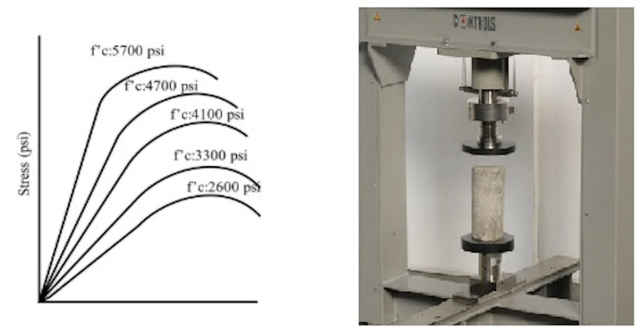

(a)

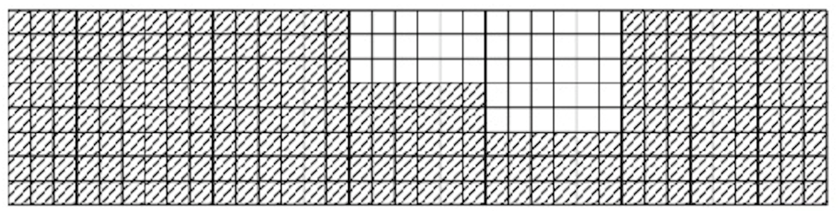

(b)

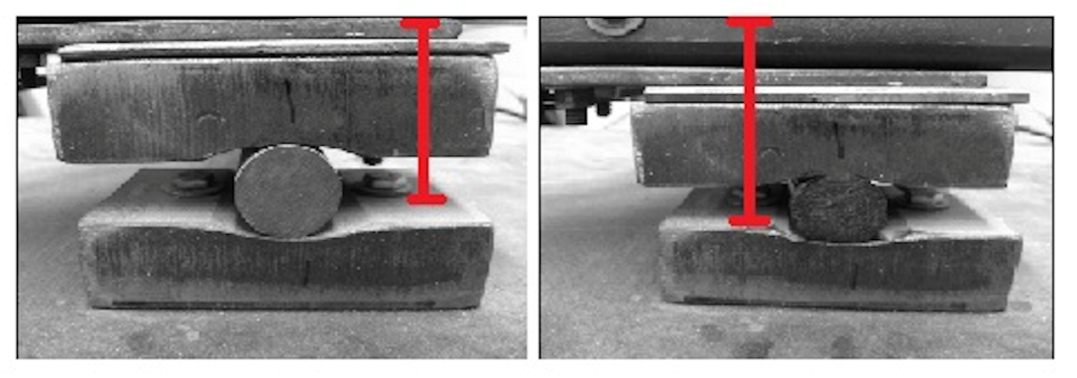

(c)

**Figure 18 List of proposed parameters for model updating, a) material properties (such as concrete compressive strength, modulus of elasticity), b) geometrical properties (section loss), c) geometrical properties (offset)**

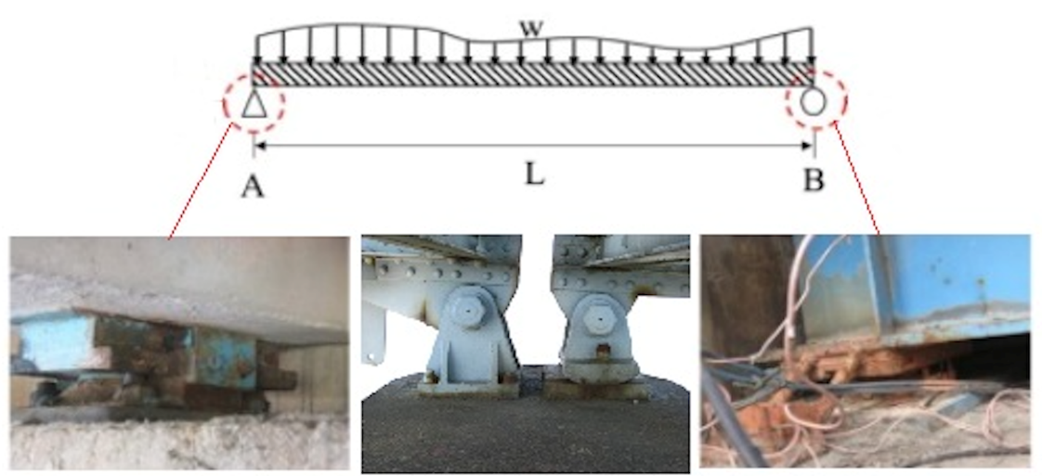

(a)

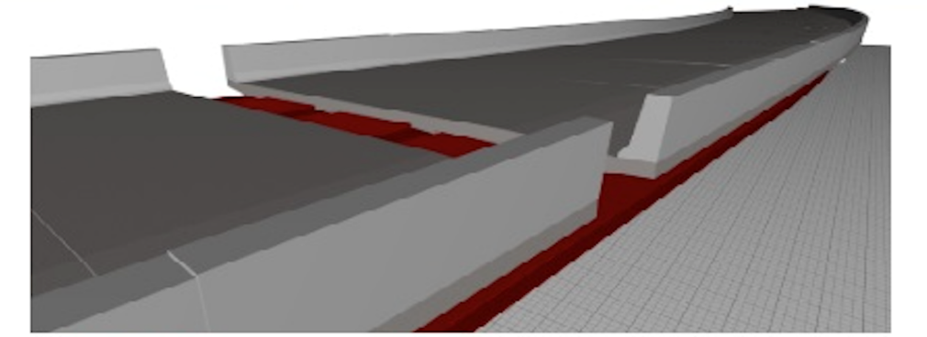

(b)

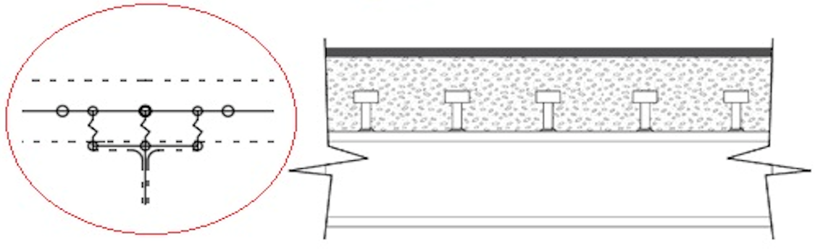

(c)

**Figure 19 List of proposed parameters for model updating, a) boundary condition (such as bearing fixity), b) continuity (barrier participation), c) continuity (composite action)**

### 4. Model Updating

The model updating process within structural engineering, which is commonly referred to as structural identification (St-Id), was first introduced in the late 1970s (Liu and Yao 1978) and for five decades it has remained an active area of research (Chen and Garba 1980; Imregun and Visser 1991; Hjelmstad et al. 1992; Mottershead and Friswell 1993; Beck and Katafygiotis 1998; Sanayei et al. 1999; Mares et al. 2000; Brownjohn et al. 2003; Ching and Chen 2007; Dubbs and Moon 2015; Yarnold and Moon 2015; Yarnold et al. 2015, among others). Traditionally, model updating has generally been carried out using a “single-model” approach in which parameters are incrementally modified to bring the model into better agreement with data obtained from the physical structure of interest. Once the data, model form/resolution, and updating parameters have been selected, the available model updating approaches can be distinguished based on the selection of the objective function and the approach to optimization.

The objective function represents the quantification of the differences between the model output and the available data. Common approaches include the sum or products of deterministic error as well as probabilistic approaches that combine the likelihood of the model, given the observed data. In both cases the updating is driven to either minimize (in the case of deterministic error functions) or maximize (in the case of probabilistic likelihood functions) the objective function. To accomplish this, the model updating process incorporates an optimization strategy, which are typically distinguished as gradient-based or non-gradient-based. Gradient-based optimization algorithms are very efficient, but are prone to getting stuck in local minima/maxima and thus are generally run multiple times with different parameter starting points. The non-gradient-based optimization algorithms are not prone to getting stuck in local minima/maxima, but are generally far more computationally expensive as they require a significant increase in model executions. Examples of such optimization algorithms include simulated annealing, particle swarm, and genetic algorithms.

#### 4.1. Demand Models

A key challenge associated with single-model approaches is the potential for the outcome to be non-unique. That is, numerous models may be tuned to equally match the observed data, but they may provide different estimates of the desired simulation results (e.g. capacity evaluation). While avoiding the use of overly complex models can greatly mitigate this to a degree, as discussed previously, in most cases this strategy is not feasible as the attributes/responses that must be simulated necessitate a model resolution that is not practical to match with experimental observations. As a result, a significant disparity between the experiment and model resolutions is inherent in nearly all applications focused on civil structures, and thus unique solutions are rarely, if ever, possible.

This challenge has produced growing interest in multiple-model (MM) St-Id approaches, which aim to quantify the level of non-uniqueness associated with the resulting predictions. In general, these methods differ from more conventional approaches in that they do not aim to produce a single “calibrated” model. Rather, their aim is to produce a plausible set of predictions, given the prior knowledge about the structure and the observed data. In general, the process includes three primary steps: (1) development of a set of candidate models, (2) weighing of the candidate models based on their agreement with observed data, and (3) prediction of the desired attribute or response (which is assumed to carry the same weight as the model that produced it).

The most common example of MM St-Id is Bayesian model updating, in which sampling is carried out based on either Monte Carlo or Markov Chain Monte Carlo approaches and models are weighed using Bayes Theorem (Beck and Katafygiotis 1998; Chen et al. 2000). Another notable example of MM St-Id develops candidate models using a Latin Hypercube sampling approach and weighs them using a binary (zero or one) scale based on specific threshold levels (Robert-Nicoud et al. 2005a,b; Smith and Saitta 2008; Kripakaran and Smith 2008; Goulet et al. 2010). These methods offer clear, conceptual benefits over single-model approaches, but they are far more computationally expensive as they require a significant increase in the number of model executions. In the following paragraphs, each of the proposed MM St-Id approaches are briefly summarized.

##### 4.1.1. Model Updating #1 - Latin Hypercube Sampling (LHS), Percent Error Weighing

In this method, a full-factorial sampling and weighing based on the inverse of the sum of relative errors are employed. Meaning that for each round of simulation, a random value of each updating parameter is selected to be fed to the model. The LHS (McKay et al. 1979; Stein 1987) would be carried out by segmenting each parameter into an *n* number of bins with equal probabilities. As exemplified in Table 6, all parameters are assumed to have uniform probability distributions within their bounds. In addition, a final parameter, such the elastic modulus of steel, may be selected for inclusion to provide a means for error screening. Given the relatively small variability with this parameter, and its significant influence over the responses of interest, it has the capability to provide an important check (Pan et al. 2011) against overall bias errors in the model. A random sample will be then drawn from each bin for each parameter. The resulting samples for each parameter would be randomly combined to define a population of *n* models. To ensure the parameters converged to a stable representation of the population, different sample sizes will be employed. A trial-error will determine the appropriate size. Once all the models are executed, they will be combined based on their weights. The weight of each model could be then computed using the following equation:

$$M_{i}={\left(\sum_{j=1}^{7}{\left|\frac{f_{j}^{exp}-f_{i,j}^{model}}{f_{j}^{exp}}\right|}+\left|1-{MAC}_{i,j}\right|\right)}^{-1} (1)$$

Where $M_{i}$ = weight; $f_{j}^{exp}$ is the *j*th experimental; natural frequencies; $f_{i,j}^{model}$ is the *j*th natural frequency associated with Model *i;* and ${MAC}_{i,j}$ is the Modal Assurance Criteria (MAC) value associated with the *j*th mode for model *i.* Mac values are a measure of the correlation between two shape functions and are commonly used to pair experimental and analytical mode shapes during the model updating process (Dubbs and Moon 2015; Weidner 2012). A different approach of error threshold weighing could be also taken to weigh the models. For instance, the weights are assigned to the samples using an error threshold approach as defined by Goulet et al. (2010). This method takes a model falsification approach in which models that do not fall within predetermined error thresholds are eliminated from further consideration (i.e., assigned a weight of 0). Models that fall within all thresholds are assigned a weight of 1. For final verification, both the dynamic (observable) responses and static (unobservable) responses could be captured for this implementation to allow the merits of each approach to be established. For further information, refer to Dubbs and Moon (2015).

**Table 6 Sample of updating parameters and anticipated bounds**

|  |  |  |
| --- | --- | --- |
| **Parameter** | **Lower bound** | **Upper bound** |
| **E** | 0.7E0 | 1.3E0 |
| **f’c (ksi)** | 4 | 6 |
| **Longitudinal stiffness (kip/in.)** | 0 | 50 |
| **Rotational stiffness (%)** | 70 | 100 |

##### 4.1.2. Model Updating #2 (Bayesian) - Markov Chain Monte Carlo Sampling (MCMC), Bayes Theorem Weighing

This approach is commonly termed Bayesian model updating and involves the use of MCMC sampling with model weights defined by Bayes theorem (Chen et al. 2000; Geyer 1992; Beck and Au 2002; Green 2003; Ching and Chen 2007; Glaser et al. 2007). A primary advantage of MCMC is its ability to concentrate samples in regions of high likelihood with respect to observations, and thus reduce the samples required to characterize the relevant model space. The primary challenge of this approach is related to its computation costs. Depending on the number and influence of the parameter selected for updating, achieving convergence may require thousands or tens of thousands of model executions. Adaptive methods that modify the proposal function within the MCMC sampling scheme have shown to be effective at improving efficiency and will be examined throughout this study. Further details associated with this method can be found in Dubbs (2012).

#### 4.2. Capacity Models

Similar to demand model updating approaches, capacity fiber models could be sampled and weighed for updating purposes. Due to the uncertain nature of NDE results, which is the primary information used to update capacity models, it is recommended to integrate the associated uncertainties during the updating procedures. To that extent, a comprehensive uncertainty analysis will be conducted on the past NDE data (mainly collected by LTBP program and NDE Virtual Lab) to distinguish the most appropriate distribution for each NDE technique. The proposed method will leverage Monte Carlo simulation to estimate the influence of the uncertainties identified through NDE on the estimation of member capacity. In the Monte Carlo simulation, key parameters are sampled from their probability distributions and used within the simulation model to identify the resulting variability of the model output (in this case member capacity). Monte Carlo is a class of computational algorithms that rely on repeated random sampling. In the proposed model updating for capacity estimation, as shown in Fig. 20a, the simulation process will be performed numerous times (*n*) and in each run, one sample data for each variable parameter is randomly selected from its representative distribution.

More specifically, the proposed approached to incorporate NDE data within the capacity estimation process is outlined in the following:

1. Fit NDE/SHM data with appropriate probability distributions, taking care to maintain spatial/time/temperature relationships.
2. Using either Monte Carlo simulation or Latin Hypercube Sampling (LHS), generate a set of random samples for each of the parameters defined by the NDE/SHM data.
3. Feed the set of parameters into the capacity model and compute the moment-curvature relationship for each parameter set.
4. Repeat steps 2-3 (*n*) times.
5. Assess the convergence of the moment-curvature relationships. If it has not converged, return to step 2 and obtain additional samples.
6. Once the moment-curvature relationships have converged, utilize the resulting distributions within the load rating process.

Fig. 20 below represents schematic of the above steps to convey how the NDE and SHM would be simultaneously incorporated for model updating.

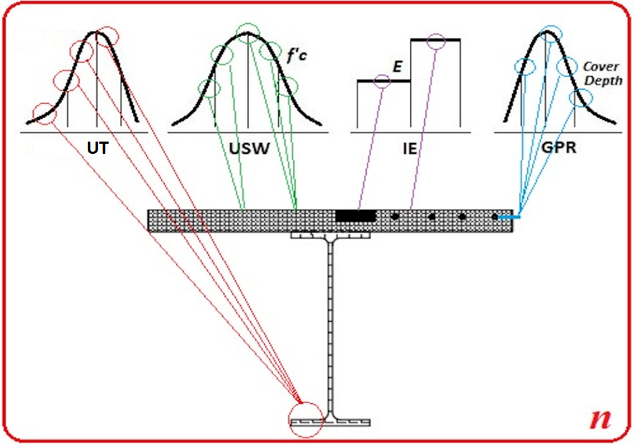

(a)

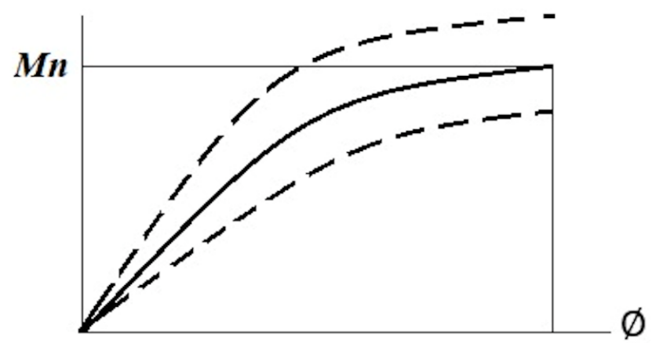

(b)

**Figure 20 a) Schematic of proposed model updating approach for capacity evaluation, b) sample outcome of the model updating approach for capacity evaluation**

## Proposed Integration Strategies

Based on the discussion of the proposed integration framework (Fig. 3), eight different integration strategies are proposed for inclusion within this research effort. As indicated in Table 7 below, each of the proposed integration strategies (IS) are created based on different combinations of the approaches outlined under the previous four subsections.

**Table 7 Proposed NDE-SHM integration strategies**

|  |  |  |  |
| --- | --- | --- | --- |
| **Integration Strategy (IS)** | **Type of Data** | **Model Resolution** | **Model Updating** |
| **IS#1** | SHM data for demand models, NDE for capacity models | Element level model (single beam element for girder) | LHS + percent weighing |
| **IS#2** | SHM data for demand models, NDE for capacity models | Element level model (single beam element for girder) | MCMC + Bayes rule |
| **IS#3** | SHM data for demand models, NDE for capacity models | Refined model (shell element for girder) | LHS + percent weighing |
| **IS#4** | SHM data for demand models, NDE for capacity models | Refined model (shell element for girder) | MCMC + Bayes rule |
| **IS#5** | SHM + NDE (damage functions) for demand models, NDE for capacity models | Element level model (single beam element for girder) | LHS + percent weighing |
| **IS#6** | SHM + NDE (damage functions) for demand models, NDE for capacity models | Element level model (single beam element for girder) | MCMC + Bayes rule |
| **IS#7** | SHM + NDE (damage functions) for demand models, NDE for capacity models | Refined model (shell element for girder) | LHS + percent weighing |
| **IS#8** | SHM + NDE (damage functions) for demand models, NDE for capacity models | Refined model (shell element for girder) | MCMC + Bayes rule |

**References**

* AAHSTO (2018). “Manual for Bridge Evaluation (MBE).” American Association of State Highway and Transportation Officials (AASHTO), 3rd Ed., Washington, DC.
* AASHTO (2007). “Maintenance Manual for Roadways and Bridges.” American Association of State Highway and Transportation Officials (AASHTO), 4th Ed., Washington, DC.
* AASHTO (2017). “LRFD Bridge Design Specifications.” American Association of State Highway and Transportation Officials (AASHTO), 8th Ed., Washington, DC.
* ACI 228.2R (1998). “Nondestructive Test Methods for Evaluation of Concrete in Structures.” American Concrete Institute Committee (ACI) 228.2R-98.
* [Agdas](https://ascelibrary.org/author/Agdas%2C+Duzgun), D., [Rice](https://ascelibrary.org/author/Rice%2C+Jennifer+A), J. A., Martinez, J. R, and [Lasa](https://ascelibrary.org/author/Lasa%2C+Ivan+R), I. R. (2016). “Comparison of Visual Inspection and Structural-Health Monitoring As Bridge Condition Assessment Methods.” [J. Performance of Constructed Facilities](https://ascelibrary.org/journal/jpcfev), 30(3), https://doi.org/10.1061/(ASCE)CF.1943-5509.0000802
* Andrade C. C. (1996). “Corrosion Rate Monitoring in the Laboratory and On Site.” Const. Bldg. Mater., 10(5), 315-328.
* ASNT (2005). “American Society of Nondestructive Testing (ASNT) Handbook.” 3rd Ed., 7, Ultrasonic Testing (ET).
* ASTM C469/C469M-14 (2014). “Standard Test Method for Static Modulus of Elasticity and Poisson’s Ratio of Concrete in Compression.” American Society for Testing and Materials (ASTM) International, West Conshohocken, PA.
* ASTM C615/C615M-18e1 (2018). “Standard Specification for Granite Dimension Stone.” American Society for Testing and Materials (ASTM) International, West Conshohocken, PA.
* ASTM C805-02 (2002). “Standard test method for rebound number of hardened concrete.” American Society for Testing and Materials (ASTM) International, West Conshohocken, PA.
* ASTM C876-91 (1999). “Standard Test Method for Half Cell Potentials of Reinforcing Steel in Concrete.” American Society for Testing and Materials (ASTM) International, West Conshohocken, PA.
* ASTM C944/C944M-12 (2012). “Standard Test Method for Abrasion Resistance of Concrete or Mortar Surfaces by the Rotating-Cutter Method.” American Society for Testing and Materials (ASTM) International, West Conshohocken, PA.
* ASTM C1152/C1152M-04(2012)e1 (2012). “Standard Test Method for Acid-Soluble Chloride in Mortar and Concrete.” American Society for Testing and Materials (ASTM) International, West Conshohocken, PA.
* ASTM C1383-04 (2010). “Standard Test Method for Measuring the P-Wave Speed and the Thickness of Concrete Plates Using the Impact-Echo Method.” American Society for Testing and Materials (ASTM) International, West Conshohocken, PA.
* ASTM D4788-03 (2013). “Standard Test Method for Detecting Delamination in Bridge Decks Using Infrared Thermography.” American Society for Testing and Materials (ASTM) International, West Conshohocken, PA.
* ASTM D4580-03 (2007). “Standard Practice for Measuring Delamination in Concrete Bridge Decks by Sounding.” American Society for Testing and Materials (ASTM) International, West Conshohocken, PA.
* ASTM D6087-08 (2008). “Standard Test Method for Evaluating Asphalt-Covered Concrete Bridge Decks Using Ground Penetrating Radar.” American Society for Testing and Materials (ASTM) International, West Conshohocken, PA.
* ASTM D7046-11 (2011). “Standard Guide for Use of the Metal Detection Method for Subsurface Exploration.” American Society for Testing and Materials (ASTM) International, West Conshohocken, PA.
* ASTM D7913/D7913M-14 (2014). “Standard Test Method for Bond Strength of Fiber-Reinforced Polymer Matrix Composite Bars to Concrete by Pullout Testing.” American Society for Testing and Materials (ASTM) International, West Conshohocken, PA.
* ASTM E1417-11 (2011). “Standard Practice for Liquid Penetrant Testing.” American Society for Testing and Materials (ASTM) International, West Conshohocken, PA.
* ASTM E165-12 (2012). “Standard Practice for Liquid Penetrant Examination for General Industry.” American Society for Testing and Materials (ASTM) International, West Conshohocken, PA.
* ASTM E2884-13e1 (2013). “Standard Guide for Eddy Current Testing of Electrically Conducting Materials Using Conformable Sensor Arrays.” American Society for Testing and Materials (ASTM) International, West Conshohocken, PA.
* ASTM E647-13ae1 (2013). “Standard Test Method for Measurement of Fatigue Crack Growth Rates.” American Society for Testing and Materials (ASTM) International, West Conshohocken, PA.
* ASTM E709-08 (2008). “Standard Guide for Magnetic Particle Testing.” American Society for Testing and Materials (ASTM) International, West Conshohocken, PA.
* ASTM G109-07 (2013). “Standard Test Method for Determining Effects of Chemical Admixtures on Corrosion of Embedded Steel Reinforcement in Concrete Exposed to Chloride Environments.” American Society for Testing and Materials (ASTM) International, West Conshohocken, PA.
* AWS D1.5. (2010). “Bridge Welding Code.” American Welding Society, Miami, FL.
* Azari, H., Yuan, D., Nazarian, S., and Gucunski, N., (2012). “Sonic Methods to Detect Delamination in Concrete Bridge Decks: Impact of Testing Configuration and Data Analysis Approach.” Transportation Research Record (TRR): J. Trans. Res. Board, No. 2292, 113-124.
* Babanajad, S., Bai, Y., [Wenzel,](https://journals.sagepub.com/doi/10.1177/0361198118781396) H., [Wenzel](https://journals.sagepub.com/doi/10.1177/0361198118781396), M., [Parvardeh](https://journals.sagepub.com/doi/10.1177/0361198118781396), H., [Rezvani,](https://journals.sagepub.com/doi/10.1177/0361198118781396) A., [Zobel](https://journals.sagepub.com/doi/10.1177/0361198118781396), R., [Moon](https://journals.sagepub.com/doi/10.1177/0361198118781396), F., [Maher,](https://journals.sagepub.com/doi/10.1177/0361198118781396) A. (2018). “Life Cycle Assessment Framework for the U.S. Bridge Inventory.” J. Trans. Res. Board, 2672(12), 1-11.
* Bäßler, R., Burkert, A., Frølund, T. and Klinghoffer, O. (2003). "Usage of GPM-Portable Equipment for Determination of Corrosion Stage of Concrete Structures." Proceeding of NACE Corrosion Conference, 3388, San Diego, CA.
* Bayraktar, A., Altunisik, A. C., Sevim, B., and Turker, T. (2009). “Modal Testing, Finite-Element Model Updating, and Dynamic Analysis of an Arch Type Steel Footbridge." J Performance Const. Facilities, 23(2), 81-89.
* Beck, J. L., and Au, S.-K. (2002). “Bayesian updating of structural models and reliability using Markov chain Monte Carlo simulation.” J. Eng. Mech., 128(4), 380–391.
* Beck, J. L., and Katafygiotis, L. (1998). “Updating models and their uncertainties. I: Bayesian statistical framework.” J. Eng. Mech., 124(4), 455–461.
* Bell, E. S., and M. Sanayei, et al. (2007). "Multiresponse Parameter Estimation for Finite-Element Model Updating Using Nondestructive Test Data." J. Struct. Eng., 133(8), 1067-1079.
* Bray, D.E., and Stanley, R.K. (1989). “Nondestructive Evaluation—A Tool in Design, Manufacturing and Service.” McGraw Hill, New York, NY.
* Brownjohn, J. M. W., Moyo, P., Omenzetter, P., and Lu, Y. (2003). “Assessment of Highway Bridge upgrading by dynamic testing and finite-element model updating.” J. Bridge Eng., 8(3), 162–172.
* Chen, J., and Garba, J. (1980). “Analytical model improvement using modal test results.” AIAA, 18(6), 684–690.
* Chen, M.-H., Shao, Q.-M., and Ibrahim, J. G. (2000). “Monte Carlo methods in Bayesian computation.” Springer, New York.
* Ching, J., and Chen, Y. -C. (2007). “Transitional Markov chain Monte Carlo method for Bayesian model updating, model class selection, and model averaging.” J. Eng. Mech., 133(7), 816–832.

* [Conde, B.,](https://www.sciencedirect.com/science/article/pii/S0141029617306077" \l "!) [Ramos, L. F.,](https://www.sciencedirect.com/science/article/pii/S0141029617306077" \l "!) [Oliveira, D.V.,](https://www.sciencedirect.com/science/article/pii/S0141029617306077" \l "!) [Riveiro, B. V., and](https://www.sciencedirect.com/science/article/pii/S0141029617306077" \l "!) [Soll,](https://www.sciencedirect.com/science/article/pii/S0141029617306077" \l "!) M. (2017). “Structural assessment of masonry arch bridges by combination of non-destructive testing techniques and three-dimensional numerical modelling: Application to Vilanova Bridge.” [Eng. Struct.](https://www.sciencedirect.com/science/journal/01410296)[,](https://www.sciencedirect.com/science/journal/01410296/148/supp/C) 148(1). 621-638.
* Dubbs, N. C. (2012). “Development, validation, and assessment of a multiple model structural identification method.” Ph.D. thesis, Dept. of Civil, Architectural, and Environmental Engineering, Drexel Univ., Philadelphia.
* Dubbs, N. C., and Moon, F. L. (2015). “Comparison and Implementation of Multiple Model Structural Identification Methods.” J Struct. Eng., 141(11), https://doi.org/10.1061/(ASCE)ST.1943-541X.0001284
* Elsener, B., Hug, A., Bürchler, D. and Böhni, H. (1996). "Evaluation of localized corrosion rate on steel in concrete by galvanostatic pulse technique." in: Corrosion of Reinforcement in Concrete Construction (Page, C. L., Bamforth, P., Figg, J. W., Ed.), Society of Chemical Industry, London, England, 264.
* Geyer, C. (1992). “Practical Markov chain Monte Carlo.” Stat. Sci., 7(4), 473–483.
* [Gheitasi](https://ascelibrary.org/author/Gheitasi%2C+Amir), A., and [Harris](https://ascelibrary.org/author/Harris%2C+Devin+K), D. K. (2015). “Integration of Element Inspection Data in Model Updating and Performance Evaluation of In-Service Bridge Superstructures.” SEI Structures Congress, Portland, OR, 392-403.

* [Ghodoosi, F.,](https://www.sciencedirect.com/science/article/pii/S0926580517305678" \l "!) [Bagchi, A.,](https://www.sciencedirect.com/science/article/pii/S0926580517305678#!) [Zayed,](https://www.sciencedirect.com/science/article/pii/S0926580517305678" \l "!) T., and [Hosseini](https://www.sciencedirect.com/science/article/pii/S0926580517305678#!), M. R. (2018). “Method for developing and updating deterioration models for concrete bridge decks using GPR data.” [Automation in Construction](https://www.sciencedirect.com/science/journal/09265805), 91, 133-141.
* Ghorbanpoor, A., Borchelt, R., Edwards, M., and Abdel Salam, E. (2000). “Magnetic-Based NDE of Prestressed and Post-Tensioned Concrete Members: The MFL System.” FHWA-RD-00-026, Federal Highway Administration, Mclean, VA.
* Glaser, R. E., Lee, L. C., Nitao, J. J., Hickling, T. L., and Hanley, W. G. (2007). “Markov chain Monte Carlo-based method for flaw detection in beams.” J. Eng. Mech., 133(12), 1258–1267.
* Goulet, J., Kripakaran, P., and Smith, I. (2010). “Multimodel structural performance monitoring.” J. Struct. Eng., 136(10), 1309–1318.
* Green, P. (2003). “Trans-dimensional Markov chain Monte Carlo.” Highly structured stochastic systems, Oxford University Press, Bristol, UK.
* Gucunski, N., Imani, A., and Romero, F. et al. (2013). “Nondestructive Testing to Identify Concrete Bridge Deck Deterioration.” Report S2- R06A-RR-1, SHRP2 Renewal Research, Transportation Research Board, Washington, DC.
* Gucunski, N., Romero, F., Kruschwitz, S., Feldmann, R., Parvardeh, H. (2011). “Comprehensive Bridge Deck Deterioration Mapping of Nine Bridges by Nondestructive Evaluation Technologies.” Project SPR-NDEB(90)-8H-00, Center for Advanced Infrastructure and Transportation (CAIT), Rutgers University, Piscataway, NJ.
* Gucunski, N., Pailes, B., Kim, J., Azari, H., and Dinh, K. (2016). “Capture and Quantification of Deterioration Progression in Concrete Bridge Decks through Periodical NDE Surveys.” J. Infrastruct. Syst., 23(1), B401600.
* Hagemaier, J.D. (1990). “Fundamentals of Eddy Current Testing.” The American Society for Nondestructive Testing Inc., Columbus, OH.
* He, X., Moaveni, B., Conte, J., Elgamal, A., and Masri, S. (2009). “System identification of Alfred Zampa Memorial Bridge using dynamic field test data.” J. Struct. Eng., 135(1), 54–66.
* Hjelmstad, K., Wood, S., and Clark, S. (1992). “Mutual residual energy method for parameter estimation in structures.” J. Struct. Eng., 118(1), 223– 242.
* Huang, M., Jiang, L., Liaw, K.P., Brooks, R.C., Seeley, R. and Klarstrom, L.D. (1998). "Using Acoustic Emission in Fatigue and Fracture Materials Research." The Minerals, Metals & Materials Society, Pittsburgh, PA.
* Imregun, M., and Visser, W. J. (1991). “A review of model updating techniques.” Shock Vib. Digest, 23(1), 9–20.
* [Jang](https://ascelibrary.org/author/Jang%2C+Shinae), S., [Li](https://ascelibrary.org/author/Li%2C+Jian), J., and [Spencer, B. F. (2013).](https://ascelibrary.org/author/Spencer%2C+Billie+F) “Corrosion Estimation of a Historic Truss Bridge Using Model Updating.” [J.](https://ascelibrary.org/journal/jbenf2) Bridge Eng., 18(7), <https://doi.org/10.1061/(ASCE)BE.1943-5592.0000403>
* Kozlov, V.N., Samokrutov, A. A., Shevaldykin, V. G. (2006). "Ultrasonic Equipment for Evaluation of Concrete Structures Based on Transducers with Dry Point Contact." In Proceedings of the NDE Conference on Civil Engineering, St. Louis, MO.
* Kripakaran, P., and Smith, I. F. C. (2008). “Damage identification in truss bridges using multiple models.” 15th EG-ICE Workshop on Intelligent Computing in Engineering (ICE08), Plymouth, U.K.
* Liu, S. C., and Yao, J. T. P. (1978). “Structural identification concept.” J. Struct. Div., 104(12), 1845–1858.
* Maierhofer, C., Arndt, R., Rollig, M., Rieck, C., Walther, A., Scheel, H., and Hillemeier, B. (2006). "Application of Impulse-Thermography for Non-Destructive Assessment of Concrete Structures," Cem. Con. Composites, 28(4), 393-401.
* Mares, C., Mottershead, J. E., and Friswell, M. I. (2000). “Selection and updating of parameters for the GARTEUR SM-AG19 testbed.” Proc. Int. Conf. for Noise and Vibration Engineering (ISMA), 25th Int. Seminar on Modal Analysis, 635–640.
* Mariscotti, M.A.J., Jalinoos, F., Frigerio, T., Ruffolo, M., and Thieberger, P. (2009). "Gamma-Ray Imaging for Void and Corrosion Assessment." Concrete International, 31(11), 48-53.
* Masceri, D. R. (2015). “Examination of Bridge Performance through the Extension of Simulation Modeling and Structural Identification to Large Populations of Structures.” Ph.D. thesis, Dept. of Civil, Architectural, and Environmental Engineering, Drexel Univ., Philadelphia.
* McGogney, C. (1995). “Magnetic Flux Leakage for Bridge Inspection.” Nondestructive Testing Methods for Civil Infrastructure, A Collection of Expanded Papers on Nondestructive Testing from Structures Congress '93, 31-44.
* McKay, M. D., Beckman, R. J., and Conover, W. J. (1979). “A comparison of three methods for selecting values of input variables in the analysis of output from a computer code.” Technometrics, 21(2), 239–245.
* Millard, S.G., and DTI DME 5.1 Consortium (2003). “Measuring the Corrosion Rate of Reinforced Concrete Using Linear Polarisation Resistance.” Good Practice Guide No. 132, Concrete Society, pp. 36-38.
* Moore, M., Phares, B., and Washer, G. (2004). “Guidelines for Ultrasonic Inspection of Hanger Pins.” FHWA, USDOT, Washington, DC.
* Morassi, A., and Stefano, T. (2008). “Dynamic testing for structural identification of a bridge.” J. Bridge Eng., 13(6), 573–585.
* Mottershead, J. E., and Friswell, M. I. (1993). “Model updating in structural dynamics: A survey.” J. Sound Vib., 167(2), 347–375.
* NCHRP Report 234 (1998). “Manual for Bridge Rating through Load Testing.” NCHRP Research Results Digest, Transportation Research Board, National Research Council, Washington, DC.
* NCHRP Report 312 (1988). “Condition Surveys of Concrete Bridge Components.” NCHRP Report 312, Transportation Research Board, National Research Council, Washington, DC.
* Olympus NDT, Inc. (2007). “Advances in Phased Array Ultrasonic Technology Applications” Waltham, MA.
* Pan, Q., Grimmelsman, K., Moon, F., and Aktan, E. (2011). “Mitigating epistemic uncertainty in structural identification: Case study for a longspan steel arch bridge.” J. Struct. Eng., 137(1), https://doi.org/10.1061/(ASCE)ST.1943-541X.0000248
* Pimentel, M., Figueiras, J., Mariscotti, M., Thieberger, P. (2010). "Gamma-Ray Inspection of Post Tensioning Cables in a Concrete Bridge." Structural Faults and Repair, 13th International Conference, Edinburgh, Scotland.
* Robert-Nicoud, Y., Raphael, B., Burdet, O., and Smith, I. F. C. (2005a). “Model identification of bridges using measurement data.” Comput. Aided Civ. Infrastruct. Eng., 20(2), 118–131.
* Robert-Nicoud, Y., Raphael, B., and Smith, I. (2005b). “System identification through model composition and stochastic search.” J. Comput. Civ. Eng., 19(3), 239–247.
* [Sanayei](https://ascelibrary.org/author/Sanayei%2C+Masoud), M., Bell, E. S., [Javdekar](https://ascelibrary.org/author/Javdekar%2C+Chitra+N), C. N., [Edelmann](https://ascelibrary.org/author/Edelmann%2C+Jennifer+L), J. L., and Slavsky, E. (2006). “Damage Localization and Finite-Element Model Updating Using Multiresponse NDT Data.” [J](https://ascelibrary.org/journal/jbenf2) Bridge Eng., 11(6), <https://doi.org/10.1061/(ASCE)1084-0702(2006)11:6(688)>
* Sanayei, M., McClain, J., Wadia-Fascetti, S., and Santini, E. (1999). “Parameter estimation incorporating modal data and boundary conditions.” J. Struct. Eng., 125(9), 1048–1055.
* [Sanayei](https://ascelibrary.org/author/Sanayei%2C+Masoud), M., [Phelps](https://ascelibrary.org/author/Phelps%2C+John+E), J. E., [Sipple](https://ascelibrary.org/author/Sipple%2C+Jesse+D), J. D., Bell, E. S., and [Brenner](https://ascelibrary.org/author/Brenner%2C+Brian+R), B. R. (2012). “Instrumentation, Nondestructive Testing, and Finite-Element Model Updating for Bridge Evaluation Using Strain Measurements.” [J](https://ascelibrary.org/journal/jbenf2) Bridge Eng., 17(1), <https://doi.org/10.1061/(ASCE)BE.1943-5592.0000228>
* Sansalone, M., and Carino, N. (1989). “Detecting Delamination in Concrete Slabs with and without Overlays Using the Impact-Echo Method.” ACI Mat. J., 86(2), 175–184.
* Sigurdardottir, D. H., and Glisic, B. (2013). “Neutral axis as damage sensitive feature.” Smart Mater. Struct., 22(7), http://dx.doi.org/10.1088/0964-1726/22/7/075030
* Smith, I. F., and Saitta, S. (2008). “Improving knowledge of structural system behavior through multiple models.” J. Struct. Eng., 134(4), 553–561.
* Sørensen, H.E. and Frølund, T. (2002). "Monitoring of Reinforcement Corrosion in Marine Concrete Structures by the Galvanostatic Pulse Method." Proceeding of International Conference on Concrete in Marine Environments, Hanoi, Vietnam.
* Stein, M. (1987). “Large sample properties of simulations using Latin hypercube sampling.” Technometrics, 29(2), 143–151.
* Stern M. A. (1957). “Electrochemical Polarization: A Theoretical Analysis of the Shape of Polarization Curves.” J. Electrochemical Society, 104, 56-63.
* Strategic Highway Research Program (2015). “SHRP2 NDToolbox.” (Website), Washington, DC, Accessed online: February 2015.
* Szilẚgyi, K., Borosnyói A., and Zsigovicset, I. (2010). “Rebound surface hardness of concrete: Introduction of an empirical constitutive model.” Const. Bldg. Mat., 25, 2480-2487.
* Washer, G., et al., "Environmental Factors for the Thermographic Inspection of Highway Bridges." International Conference of NDE/NDT for Highway and Bridges, Structural Materials Technology (SMT) Proceedings Oakland, CA, September 9-12, 2008.
* Weidner, J. S. (2012). “Structural Identification of a Complex Structure using both Conventional and Multiple Model Approaches.” Ph.D. thesis, Dept. of Civil, Architectural, and Environmental Engineering, Drexel Univ., Philadelphia.
* Wenzel, H., Veit-Egerer, R., and Widmann, M. (2013). “Life Cycle Analysis Applied to the New Jersey Case Study.” In Industrial Safety and Life Cycle Engineering (IRIS) (H. Wenzel, ed.), VCE Vienna Consulting Engineers ZT GmbH, Vienna, Austria, 443–464.
* Yarnold, M. and Moon, F. L. (2015). “Temperature-based structural health monitoring baseline for long-span bridges.” Eng. Struct., 86, 157-167.
* Yarnold, M. and Weidner, J. (2016). “Monitoring of a Bascule Bridge during Rehabilitation.” Bridge Struct., 12(1-2), 33-40.
* Yarnold, M., Moon, F. L., and Aktan, A. E. (2015). “Temperature-based structural identification of long span bridges.” J. Struct. Eng., 141(11), <https://doi.org/10.1061/(ASCE)ST.1943-541X.0001270>
* [Yost](https://ascelibrary.org/author/Yost%2C+J+R), J. R., [Schulz](https://ascelibrary.org/author/Schulz%2C+J+L), J. L., and [Commander](https://ascelibrary.org/author/Commander%2C+B+C), B. C. (2005). “Using NDT Data for Finite Element Model Calibration and Load Rating of Bridges.” Structures Congress, New York, NY.
* Zhou, Y., Prader,J., Weidner, J., Dubbs, N., Moon, F., and Aktan, A. E. (2012). “Structural Identification of a Deteriorated Reinforced Concrete Bridge.” J. Bridge Eng., 17(5), 774-787.

**Appendix I**

|  |  |  |
| --- | --- | --- |
| Abbreviations | | References |
| Impact Echo | IE | ASTM C1383-04; Sansalone and Carino 1989; Gucunski et al. 2013; Azari et al. 2012 |
| Electrical Resistivity | ER | Gucunski et Al. 2013; Gucunski et al. 2011 |
| Ground Penetrating Radar | GPR | ASTM D6087-08 |
| Infrared Thermography | IR | Maierhofer et al. 2006; Gucunski et Al. 2013; Washer et al. 2008; ASTM D4788-03 |
| Ultra-Surface Waves | USW | Gucunski et Al. 2013; Gucunski et al. 2011; ACI 228.2R 98; Azari et al. 2012 |
| Half Cell Potential | HCP | Gucunski et al. 2011; Gucunski et al. 2013; ASTM C876 |
| Magnetic Flux Leakage | MFL | Ghorbanpoor et al. 2000; McGogney 1995 |
| Galvabostatic Pulse Measurement | GPM | Sørensen and Frølund 2002; Elsener et al. 1996; Bäßler et al. 2003 |
| Linear Polarization | LPR | Millard 2003; Stern 1957; Andrade 1996 |
| Hammer Sound & Chain Drag | HSCD | Gucunski et al. 2013; Gucunski et al. 2011; ASTM D4580-03; Gucunski 2013 |
| Magnetometer/Profometer | MM | Bray and Stanley 1989; ASTM D7046-11 |
| Ultrasonic Pulse Echo | UPE | Kozlov et al. 2006; ACI 228.2R-98 |
| Radiography | RAD | Pimentel et al. 2010; Mariscotti et al. 2009 |
| Phased Array Ultrasonic Testing | PAUT | Olympus NDT 2007 |
| Ultrasonic Testing | UT | ASNT Handbook 2005; AWS D1.5; Moore et al. 2004 |
| Acoustic Emission | AE | ASNT Handbook 2005; Huang et al. 1998 |
| Crack Propagation Gage | CPG | ASTM E647-13ae1 |
| Dye Penetrant Testing | PT | ASTM E1417-11; ASTM E165-1 |
| Eddy Current Array Testing | ECA | ASTM E2884-13e1 |
| Eddy Current Testing | ECT | Hagemaier 1990; ASNT Handbook 2005 |
| Magnetic Particle Testing | MT | ASTM E709-08 |
| Rebound Hammer | RH | ASTM C805-02; Szilẚgyi et al. 2010 |